TABLE OF CONTENTS

PART 1. BACKGROUND OF THE COUNCIL AND STRATEGY 1

EXECUTIVE SUMMARY 1
THE COUNCIL 2
DUTIES AND RESPONSIBILITIES 2
TRUST FUND 2
PURPOSE OF FUNDS 2
THE STATEWIDE STRATEGY 3
OBJECTIVES OF THE STATEWIDE STRATEGY 3
PARTICIPATION IN THE DEVELOPMENT OF THE STATEWIDE STRATEGY 3
PUBLIC INPUT 4
2004 - 2007 STRATEGY DEVELOPMENT 4
SUMMARY OF PUBLIC INPUT ON STRATEGY 4
PUBLIC REVIEW 4
CONCLUSION 4

PART 2. THE NATURE AND EXTENT OF THE MOTOR VEHICLE THEFT PROBLEM IN ILLINOIS 5
MOTOR VEHICLE THEFT DATA SOURCES 5
TYPES OF MOTOR VEHICLE THEFT 6
NATIONWIDE COMPARISONS 8
REGIONAL COMPARISONS 11
MOTOR VEHICLE THEFT IN ILLINOIS 13
CONDITIONS OF RECOVERED MOTOR VEHICLES IN ILLINOIS 2002 16
MOTOR VEHICLE THEFT IN ILLINOIS COUNTIES 17
MOTOR VEHICLE THEFT IN ILLINOIS CITIES 20

PART 3. INPUT ON THE COUNCIL’S STRATEGY 21
SUMMARY OF TESTIMONY AND RECOMMENDATIONS 21
CONCLUSION 25

PART 4. RESPONSE TO MOTOR VEHICLE THEFT IN ILLINOIS 26
PART 5. THE COUNCIL'S FUNDING STRATEGY 29

PRIORITY PROBLEM AREAS 29
WHAT PROGRAMS HAVE BEEN FUNDED BY THE COUNCIL TO ADDRESS THE VEHICLE THEFT PROBLEM? 36
WHAT TYPES OF COSTS ARE COVERED BY TRUST FUNDS? 36
DO GRANTEE'S "MATCH" TRUST FUNDS? 37
TRUST FUNDS AWARDED SFY 1991 - SFY 2003 38
AREAS OF GREATEST NEED 39
ALLOCATION OF TRUST FUNDS FOR 2002-2003 40
CONCLUSIONS 40

APPENDICES
A.THE ILLINOIS MOTOR VEHICLE THEFT PREVENTION ACT
B. PUBLIC INPUT NOTICES
C. PANEL DISCUSSIONS PROGRAM
D. FUNDED PROGRAMS
E. 2002 TRUST FUND CONTRIBUTORS

PART 1. Background of the Council and Strategy

Executive Summary

The eleven-member Illinois Motor Vehicle Theft Prevention Council (the Council) was created by statute in 1991 to combat motor vehicle theft in Illinois. Each year it collects and administers special trust funds derived from a $1 assessment on the private passenger insurance policies written by insurers in Illinois. The Council makes grants to those who implement programs to combat or prevent vehicle theft.
To further this mission, the Council adopts a statewide motor vehicle theft prevention strategy each year derived from public comment, expert opinion, data analyses and the experiences of funded programs. The strategy describes the nature and extent of the vehicle theft problem in Illinois, the areas of the State where the problem is greatest, particular problems that the Council should focus on and the types of programs it should support. Since it began its work in 1991, vehicle theft has dropped significantly statewide, by 35 percent. Motor vehicle theft remains concentrated in the metropolitan areas of Illinois.
The Council’s funded programs have achieved impressive results as witnessed in the increases in the number of arrests, prosecutions, and convictions for vehicle theft and related offenses and reductions in the vehicle theft related offenses in Illinois. Multi-jurisdictional task forces coupled with appropriate prosecutorial resources continue to demonstrate that they are an effective law enforcement approach to vehicle theft.

In the 2004-2007 strategy, the Council continues to support law enforcement “infrastructure” programs a key to long-range planning. Auto theft investigation training programs enable officers across the state to identify and recover stolen vehicles and parts are regarded as a key ingredient to continued success. Likewise, the uniform data collection and dissemination is of critical value to programs fighting vehicle theft and will remain in place in 2004-2007.

The Council awarded 2000-2003 programs based on a look toward the financial future. The $1 assessment collected each year on private passenger vehicle insurance policies is “fixed,” however, the cost to maintain the current programs is estimated to exceed the collection in the near future. With an eye toward this, programs were advised to eliminate all unnecessary expenditures. If grantees could not fill job vacancies within a set time frame, those positions were eliminated from their awards. Every effort was made to pare down already lean programs. The financial situation is more difficult as we enter into the 2004-2007 strategy. While program costs continue to rise, and collections remain relatively stable, mandated transfers from the trust fund to the general revenue fund in FY03 and FY04 have significantly reduced the balance in the trust fund. To continue combating motor vehicle theft, the Council will need to significantly reduce the amount of funds that are granted on an annual basis.

The statewide motor vehicle theft prevention strategy was drafted utilizing the findings of the Council in 2003, available data, and input from practitioners and expert panel members. Due to careful planning and strategizing in 1991 and the ongoing efforts of the Council to keep abreast of the state’s auto theft problem, the strategy focuses the direction of the Council’s efforts for 2004-2007.

The Council

The Illinois Motor Vehicle Theft Prevention Act that took effect on January 1, 1991 created the Illinois Motor Vehicle Theft Prevention Council. The Council has the statutory responsibility to “prevent, combat and reduce motor vehicle theft in Illinois; to improve and support motor vehicle theft law enforcement, prosecution and administration of motor vehicle theft laws by establishing statewide planning capabilities for and coordination of financial resources.”

Duties and responsibilities
The primary duties and responsibilities of the Council are:
< To establish priorities for, allocate, disburse, contract for, and spend funds that are made available to the Council from any source to effectuate the purposes of the Act.

< To make grants and to provide financial support for eligible recipients to effectuate the purposes of the Act.

< To assess the scope of the problem of motor vehicle theft, including particular areas of the State where the problem is greatest and to conduct impact analyses of State and local criminal justice policies, programs, plans and methods for combating the problem.

< To develop and sponsor the implementation of statewide plans and strategies to combat motor vehicle theft and to improve the administration of motor vehicle theft laws and provide an effective forum for identification of critical problems associated with motor vehicle theft.

< To coordinate the development, adoption and implementation of plans and strategies relating to interagency or intergovernmental cooperation with respect to motor vehicle theft law enforcement.

Trust Fund
The Act established the Motor Vehicle Theft Prevention Trust Fund, a special trust fund in the State Treasury, from which the Council makes grants to eligible applicants for programs that address the problem of motor vehicle theft in Illinois.
The Act requires all insurance companies licensed to write private passenger vehicle physical damage coverage included in Class 2 and Class 3 of Section 4 of the Illinois Insurance Code to pay annually into the special trust fund an amount equal to $1.00 for each earned car year of exposure for physical damage insurance coverage during the previous calendar year.
Approximately $5.9 million is deposited into this fund on an annual basis. In FY03 a $4 million transfer was made from the trust fund to the general review fund, and in FY04 $307,000 will be transferred. Legislation was passed in 2003 assessing a 5% administrative fee to the Trust Fund. Trust Funds may be awarded to federal and State agencies, units of local government, corporations, and neighborhood, community and business organizations.

Purpose of funds
The Act provides that the Council may award these funds:
< To law enforcement and correctional agencies, prosecutors, and the judiciary for programs designed to reduce motor vehicle theft and to improve the administration of motor vehicle theft laws.

< For federal and State agencies, units of local government, corporations and neighborhood, community or business organizations for programs designed to reduce motor vehicle theft and to improve the administration of motor vehicle theft laws.

< To conduct programs designed to inform owners of motor vehicles about the financial and social costs of motor vehicle theft and to suggest to those owners’ methods for preventing motor vehicle theft.

The statewide strategy
Every four years the Council develops the Statewide Motor Vehicle Theft Prevention Strategy. The strategy includes an overview of the motor vehicle theft problem in Illinois including discussions of the nature and extent of the problem, current efforts to address the problem, resource needs, and areas of greatest need within the State. The document also includes a description of the strategy for addressing the problem including the identification of eligible program areas.
Consistent with the statewide strategy, the Council solicits and negotiates program proposals from eligible recipients. The Council gives priority to those eligible recipients with the greatest need. To that end, and based upon the statewide strategy, the following criteria are used to identify those eligible recipients with the greatest need as evidenced by: (1) An analysis of demographic, insurance, and appropriate criminal justice data; (2) Comments from the general public, federal, State, and local officials; and (3) Current research findings.
At public meetings, the Council designates programs, implementing entities, and amounts for funding which address one or more of the purposes consistent with the Act and the statewide strategy. The Council’s decision to designate programs, implementing entities, and fund amounts are based upon consideration of the following factors:
1. The recommendations and advice of its Grant Review Committee;
2. The recommendations of the Executive Director;
3. Comments from the general public, federal, State and local officials;
4. The proven effectiveness of a similar program, by making a prudent assessment of the problem to be addressed by the proposed program;
5. The likelihood that a proposed program will achieve the desired objectives, by making a prudent assessment of the concepts and implementation plans included in a proposed program and by the results of any evaluations, previous tests, or demonstrations;
6. The availability of funds;
7. The overall cost of the proposed program;
8. The implementing entity’s ability to effectively and efficiently carry out the program; and
9. The relation of the proposed program to and impact on other proposals or funded programs.

The statewide strategy is the foundation upon which the State’s efforts to combat motor vehicle theft will be built through the use of Trust Funds granted by the Council.

Objectives of the statewide strategy
The goals of the 2004-2007 Statewide Motor Vehicle Theft Prevention Strategy are to prevent, combat, and reduce motor vehicle theft in Illinois; and to improve and support motor vehicle theft law enforcement, prosecution, and administration of motor vehicle theft laws by establishing statewide planning capabilities for and coordination of financial resources.
The objectives of the strategy are:
- To reduce the number of motor vehicles stolen in the State;
- To increase the number of stolen motor vehicles recovered;
- To increase the percentage of offenses for violations of motor vehicle theft laws that results in arrests;
- To increase the percentage of offenses for violations of motor vehicle theft laws that results in criminal prosecutions;
- To increase the percentage of offenses for violations of motor vehicle theft laws that results in convictions and jail or prison sentences; and
- To reduce the recidivism of motor vehicle theft offenders.

Participation in the development of the statewide strategy
The Council is committed to ensuring that the statewide strategy reflects not only the interests and concerns of those federal, state, and local officials whose duty it is to enforce the criminal laws and to direct the administration of justice in Illinois, but also the views of the insurance industry, neighborhood and community groups, professional organizations, and citizens as well. To that end, the Council undertakes a number of measures to provide ample opportunity for comment on the statewide strategy to combat motor vehicle theft.

Public input
As an aid in the development of the strategy, the Council regularly invites public input to:
< Ensure that all appropriate agencies, units of government, private organizations and combinations thereof are considered in the development of this strategy;

< Aid in the definition of the nature and scope of the motor vehicle theft problem in Illinois;

< Help identify areas of greatest need within the State; and

< Assist in targeting potentially effective programs so that the impact of the Act is maximized.

Witnesses are asked to present oral or written testimony which:
< Identify the most pressing motor vehicle theft-related problem(s) facing their agency, taking into account the purposes of the Act.

< Present statistical data or other information that document the scope and nature of the problem(s).

< Identify the resources presently available to address this (these) problem(s).

< Discuss why a particular approach to the problem(s) show(s) more promise than other approaches.

< Discuss the relevance of recent developments in law enforcement - such as community policing, technological advances, multi-jurisdictional initiatives, etc. - to their agency’s or area’s motor vehicle theft problem(s).

2004-2007 strategy development
As part of the 2004-2007 strategy development, in January 2003, the Council solicited written input on its strategy to date and the programs it supports. The solicitation was mailed to a broad audience which included chiefs of police, sheriffs, state’s attorneys, insurance industry officials, universities, Council-funded grantees, and a various other organizations. (A copy of the notice is contained in Appendix B).
The Council convened a two-day series of discussion panels on various topics. Through this panel discussion process, the Council hoped to ensure that the 2004-2007 strategy is responsive to the nature and extent of the problem in Illinois, and that it identifies effective approaches and/or program areas that should be supported by the Council.
Seven panels were convened on May 14-15, 2003 in the Springfield, Illinois. Members of the Council and its Grant Review Committee, staff, and guests attended the sessions. (A copy of the program for the panel discussions is contained in Appendix C.) Panelists brought forth expert opinion, data and experience in a number of areas and significantly contributed to the formulation of this strategy.

Public review
The strategy itself will be discussed at an open meeting of the Council prior to its approval. Interested officials and citizens who are unable to attend that meeting are notified of their opportunity to read and comment on the strategy via the Council’s web-site, newspaper articles and posting in the state newspaper. A summary of the strategy is also prepared and distributed to the insurance industry, police chiefs, sheriffs, state’s attorneys, witnesses at the public hearings, and others after approval of it by the Council.

Conclusion
The Statewide Motor Vehicle Theft Prevention Strategy is the Council’s plan of operation for dealing with vehicle theft in Illinois. It is the result of careful analysis, public comment and review, and thoughtful discussion between stakeholders in the criminal justice community in Illinois.

Part 2: The Nature and Extent of Motor Vehicle Theft

Introduction

This part gives an overview of motor vehicle theft in the United States in general, the regions of the United States with a special concentration on the Midwest, the State of Illinois, counties in Illinois, and individual cities within the state.

Motor Vehicle Theft Data Sources

The following points discuss the data sources mentioned in this part. These sources may report on a variety of topics, but the paragraphs below describe the data these sources provide that are pertinent to this part. The data used in this part was the data most currently available from these sources.

National statistics showing the extent of motor vehicle thefts:
- National Crime Victimization Survey (NCVS): Self-report that collects victimization data and information concerning the circumstances of crime.
- Uniform Crime Reports (UCR): The FBI’s reporting system that collects data on crimes reported to approximately 17,000 city, county, and state law enforcement agencies in the United States. These reports are compiled and analyzed in a yearly publication entitled Crime in the United States.
- The National Insurance Crime Bureau (NICB) partners with insurers and law enforcement agencies to facilitate the identification, detection and prosecution of insurance criminals.
- The Insurance Institute for Highway Safety’s Highway Loss Data Institute (HLDI) studies how to decrease the number of motor vehicle accidents and how to reduce injuries when vehicle accidents do occur.
- The State University of New York at Albany publishes the Sourcebook of Criminal Justice Statistics, bringing together data from various sources about the criminal justice system in the United States.
- CCC Information Services provides the insurance industry with technological support and information services.
- State Farm Insurance is one of the largest insurance-providers in the United States.
- U.S. Census Bureau provided population data, including data on age, sex, race and Hispanic origin.

Local statistics reporting motor vehicle theft in Illinois:
- Law Enforcement Agencies Data System (LEADS): The Illinois State Police LEADS system is a computerized telecommunications system that provides current and valuable crime-related information to the law enforcement agencies and criminal justice community in Illinois. The Motor Vehicle Theft Intelligence Clearinghouse is a Council-funded program that provides analytical support for motor vehicle theft task forces and the Illinois law enforcement community using LEADS and other data sources on all motor vehicles thefts in the state, not simply those occurring in Council-funded task force areas.
- The Illinois Department of Corrections (IDOC) reports on imprisonment and sentence length.
- The Illinois State Police publishes a yearly report based on UCR data, Crime in Illinois, patterned after the FBI’s Crime in the United States.
- The Illinois Secretary of State tracks vehicle registrations for the State of Illinois.

Data Limitations
- Some data are available only at a national or state level, which makes them impossible to compare.
- Illinois does not require data to be reported on juveniles, which prevents an analysis of their involvement in vehicle theft.
- UCR tallies attempted and completed motor vehicle thefts together, whereas LEADS only considers completed motor vehicle thefts in its final figures.

Types of Motor Vehicle Theft

Motor vehicle thefts are committed for a variety of reasons. The literature in the field, as well as public comments suggests that there are four basic motives behind motor vehicle theft:

Joy Riding Theft of a vehicle for the purpose of riding around. These vehicles are usually recovered quickly and close to the location they were stolen from.
Transportation Theft of the vehicle for personal use. The stolen car is usually abandoned at the destination.
Commit Other Crimes Theft of the vehicle for transportation to and from a crime scene. The vehicle is abandoned after the crime has been committed.
Profit/Commercial Thefts Thefts perpetrated for financial gain.

There are several types of commercial theft. The following are the most common types of commercial theft:

- Counterfeit Title- Stolen vehicles can be sold through the use of counterfeit titles. The vehicles are usually sold cheaply and quickly. Frequently the offender will use “out of state” vehicle titles.

- Out-of-State/Non-Title State – There are weak and inconsistent vehicle title laws in the United States. In some states, evidence of ownership may be accomplished by registration certificate and transfer is by bill-of-sale on cars other than those sold as new. Stolen cars are registered in these states, frequently on mailed-in applications for registration documentation. In some states, no evidence of ownership is required on older model vehicles. In these operations, an application is completed which reflects the purchase of the vehicle from a fictitious person in another state. A registration certificate and license plates are obtained. The thief then sells the vehicle with this documentation of "ownership."

- Vehicle Identification Number (VIN) Switching - The intentional alteration of the VIN and the use of the fictitious VIN on counterfeit ownership or registration documents. The vehicle is then sold to an unsuspecting buyer.

- Counterfeit Manufacturers Certificate of Origin - The manufacturer of a new vehicle includes a document with the vehicle to its destination and ultimate sale called a "Manufacturers Certificate of Origin" or MCO. It is frequently referred to as the vehicle's birth certificate. In many states the MCO is the foundation for all subsequent registration and title documents. Counterfeit MCOs are used to misrepresent stolen vehicles as "new".

- Salvage Switches - These methods involve the purchase of salvage vehicles (wrecked) from insurance companies or auto wreckers. The salvage is usually dismantled but the VIN plate, license plates, title, or bill-of-sale is retained. A vehicle of similar make and model is stolen and the identity of the salvage vehicle is transferred to it. The stolen vehicle is then sold under this identity.

- Key Cuts - The offender locates a vehicle he would like to steal and obtains the public VIN from the vehicle. The offender will then go to a dealership with this information and request that a key is made for that particular vehicle. When supplying a reason, the offender usually claims he lost his keys.

- Importation Operations - These methods involve organized rings importing high-priced stolen European cars into the U.S. Again, inconsistent and sometimes ineffective foreign titling and registration laws are taken advantage of by these rings.

- Chop Shops – Chop shops are places where stolen cars are dismantled for parts and accessories that can be sold for profit. Sometimes parts are purchased by body shops or repair garages for repairs to damaged vehicles.

- Identity Theft – Identity theft occurs when someone uses personal information such as your name, social security number, or bank account number without your knowledge to commit fraud or theft. Identity thieves can purchase vehicles using the personal information of an unsuspecting victim. The victim may not receive any indication of the purchase until three months after the car has been purchased, which is usually a late payment inquiry from the finance company.

- Vehicle Cloning – A thief will copy a VIN from a legally owned vehicle sitting in a parking lot or vehicle dealership. Then the offender will steal a vehicle similar to the one from which the criminal copied the VIN. The stolen vehicle’s legitimate VIN tag is then replaced with the counterfeit one.

- Insurance Frauds - These methods involve making false vehicle theft reports for the purpose of defrauding insurance companies. Frauds can be simple or complex and elaborate schemes.

a. Simple Insurance Frauds

Simple frauds are generally considered to be afterthoughts as opposed to highly sophisticated schemes. For example, a simple fraud may be invented to cover up some other criminal offense. Sometimes allegations are made that a vehicle was stolen in order to provide an alibi in hit-and-run, drunken driving, or other offenses. Frequently, a person wrecks a vehicle and determines that a traffic accident investigation would prove risky because of his condition or the contents of the vehicle would not stand close inspection. Sometimes a fraud is committed when a vehicle owner recovers the vehicle himself but neglects to advise the insurance company, which has already compensated him. Other frauds, referred to as "Owner Give-Ups", are arranged by the vehicle owner who reaches an agreement with an accomplice to leave the vehicle and keys at a certain location. These arrangements result in the vehicle being:

    - Reported stolen and recovered stripped. This way the damaged or worn-out parts are replaced via the insurance settlement.

    - Reported stolen and recovered stripped and burned. In addition to the insurance settlement, stripped parts are sold for profit.

    - Reported stolen and not recovered.

There have also been frauds committed by vehicle owners who abandon vehicles in locations with the hope that the vehicle is stripped or stolen. Shortly after, the owner reports the vehicle stolen to the police and insurance company.

b. Complex Insurance Frauds

Complex frauds are well-planned schemes that may involve thousands of dollars. These frauds generally fall within one of four types:

1. Duplicate Title Frauds - In these kinds of frauds, the insured person sells the vehicle, obtains a duplicate vehicle title, reports the vehicle stolen, and then surrenders the duplicate title to the insurance company. This method nets proceeds from the sale of the vehicle and the vehicle theft settlement from the insurance company.

2. Counterfeit Title Frauds - In these kinds of frauds, usually a heavily financed vehicle is reported stolen and the insured presents his insurance company with a counterfeit title listing himself as the sole owner (omitting the bank or finance company as a lien).

3. Paper Vehicle Frauds - There are some states and provinces in the United States and Canada that do not have adequate vehicle title laws. Evidence of ownership is by registration certificate and transfer is by bill-of-sale on older vehicles. There is generally no inspection of the vehicle to determine the validity of the VIN and other registration information. In some instances, registrations are issued on the basis of mailed-in applications. Upon receipt of the registration, application is then made to a state issuing a title (but usually not a vehicle inspection). With title in hand, the fictitious vehicle is then insured. The final step is the theft report on the paper vehicle to the police and insurance company.

4. Salvage Vehicle Frauds - These frauds are similar to paper vehicle frauds except that they involve actual vehicles sold as salvage. These vehicles are registered and titled as "operational", insured, and then reported stolen.

The National Insurance Crime Bureau estimates that 10 percent of all reported vehicle thefts are fraudulent. Other estimates reach as high as 30 percent.

Carjacking

Carjacking, also referred to as vehicular hijacking, is the theft of a vehicle through the means of force. A significant amount of media attention has been focused on this type of vehicle theft since it presents the most harm to the victim. Statistical information regarding the occurrence of these crimes is problematic. Some law enforcement agencies record these incidents as robberies, or strong-armed robberies but others do not. As a type of motor vehicle theft, these crimes would typically fall into the "joyriding" or "for transportation" category because most often vehicles are recovered intact.

Nationwide Comparisons

According to the FBI, in 2001, approximately 1.2 million vehicles were stolen in the United States, indicating that a vehicle was stolen every 26 seconds in the United States that year. The United State experienced a 6% increase in motor vehicle thefts from 2000 to 2001. The Illinois rate decreased approximately 3 percent during the same period, from 408.1 to 396.3 offenses per 100,000 persons in the population as reported in Crime in Illinois, 2001. Also in 2001, approximately 336.9 automobiles and 86.5 trucks or buses were stolen for every 100,000 persons in the population, and according to the Sourcebook for Criminal Justice Statistics, one vehicle was stolen for every 192 vehicles registered in the United States.

As Table 1 indicates, reported motor vehicle thefts declined across the country each year from 1997 to 2000, but increased in 2001.

Table 1:
National Motor Vehicle Theft Trends, 1996 – 2001
 | TOTAL MOTOR |  | CHANGE IN RATE
YEAR | VEHICLE THEFTS | RATE PER  100,000 PERSONS | FROM PREVIOUS YEAR
1997 | 1,354,189 | 506 | -3.8
1998 | 1,242,781 | 459.8 | -9.1
1999 | 1,147,305 | 420.7 | -8.5
2000 | 1,160,002 | 412.2 | -2
2001 | 1,226,457 | 430.6 | 4.5
Source: Crime in the United States, Federal Bureau of Investigation

From 1991 through 2001, the United States experienced a 35 percent decrease overall in the vehicle theft rate, as reported by the FBI. During this time, the motor vehicle theft rate in Illinois decreased approximately 40 percent, from 661.7 to 395.9 offenses per 100,000 persons in the population as reported in Crime in Illinois.

Washington, DC had the highest motor vehicle theft rate in the United States in 2001. Among the ten states with the highest motor vehicle theft rates, western states were more represented than states from any other region. Illinois ranked 21st.

Table 2:
Ten States with the Highest Motor Vehicle
Theft Rates and Illinois State’s Ranking, 2001
 |  | RATE PER
RANK | STATE | 100,000 PERSONS
1 | Washington, DC | 1341.3
2 | Arizona | 983.6
3 | Nevada | 698.1
4 | Washington | 652.6
5 | Maryland | 595.8
6 | California | 591.4
7 | Hawaii | 550.7
8 | Florida | 548.4
9 | Michigan | 536.6
10 | Missouri | 497.6
21 | Illinois | 390.8
Source: Crime in the United States, Federal Bureau of Investigation

Table 3 depicts the ten metropolitan statistical areas (MSAs) with the highest motor vehicle theft rates per 100,000 persons in 2002. MSAs are major metropolitan areas established by the United States Census Bureau, representing not only cities and adjacent metropolitan regions, but also border areas. The City of Chicago MSA ranked 58th in motor vehicle theft rates that year.

Table 3:
Ten MSAs with the Highest Motor
Vehicle Theft Rates and the City
of Chicago’s Ranking, 2002
RANK | CITY
1 | Phoenix, Arizona
2 | Fresno, California
3 | Modesto, California
4 | Stockton-Lodi, California
5 | Las Vegas, Nevada
6 | Miami, Florida
7 | Sacramento, California
8 | Oakland, California
9 | Seattle, Washington
10 | Tacoma, Washington
58 | Chicago, Illinois
Source: National Insurance Crime Bureau

The majority of MSAs with the highest motor vehicle theft rates are in the western states of the nation. Further, the National Insurance Crime Bureau (NICB) reports that nine of the top ten metropolitan areas for vehicle theft are in or near ports and Canadian and Mexican borders, indicating that a motive behind motor vehicle theft may be illegal exporting. The NICB estimates that approximately 200,000 stolen vehicles are illegally exported out of the country each year, and that trafficking in stolen motor vehicles is the second most profitable criminal activity behind drug-dealing.

It is important to note here that the City of Chicago, which accounted for 60 percent of statewide motor vehicle thefts in 2002, is 500 miles from Toronto, Canada’s largest city.

Motor vehicle theft is the most costly property crime in the United States according to State Farm Insurance. Twelve percent of property crimes in the United States in 2001 were motor vehicle thefts. State Farm also reports that in 2001, the cost of vehicle theft to consumers was more than 7.5 billion annually. If the vehicle theft "industry" was organized as one company, its revenue would place it among the top 60 largest corporations in the nation.

According to the National Crime Victimization Survey: Criminal Victimization 2001, Changes 2000-01 with Trends 1993-2001, among property crimes, motor vehicle theft was the most highly reported to police. The number of motor vehicle thefts in the country in 2001 was nine for every 1,000 households. Although this is the lowest number recorded by Victimization Survey, this number is not significantly different from the level in 2000. In 2001, there were eight motor vehicle thefts for every 1,000 white households, 16 motor vehicle thefts for every 1,000 black households, eight vehicle thefts for every 1,000 non-Hispanic households of all races, and 20 auto thefts for Hispanic households of all races.

According to a 2002 study by the Insurance Institute for Highway Safety, the Acura Integra, two-door and four-door models, had the most insurance theft losses and claims among 1999-2001 models.

Table 4:
Passenger Vehicles with the Highest
Theft Claim Frequencies, 1999-2001 Models
 |  | CLAIMS PER 1,000
MAKE/SERIES | SIZE/TYPE | INSURED VEHICLE YEARS
Acura Integra | Small 2-Door/4-Door Car | 21.7
Jeep Wrangler | Small 2-Door SUV | 8.5
Jeep Cherokee 4WD | Small 4-Door SUV | 6.6
Honda Prelude | Small 2-Door Car | 6.4
Mitsubishi Mirage | Small 2-Door Car | 6.2
Chrysler 300M | Large 4-Door Car | 5.9
Hyundai Tiburon | Small 2-Door Car | 5.5
Dodge Intrepid | Large 4-Door Car | 5.1
Mitsubishi Mirage | Small 4-Door Car | 5.1
Chrysler LHS | Large 4-Door Car | 5
Source: Insurance Institute for Highway Safety, Highway Loss Data Institute

Table 5 lists the ten most stolen vehicles in the United States in 2002, which, in general, are also the most popular vehicles on the road. Tables 4 and 5 differ because the Insurance Institute for Highway Safety determines the vehicles with the worst theft losses by comparing the number of theft claims by make and model relative to the number of each make and model insured.

Table 5:
Ten Most Stolen Vehicles
in the United States, 2002
RANK | YEAR | MAKE | MODEL
1 | 1989 | Toyota | Camry
2 | 1991 | Toyota | Camry
3 | 1990 | Toyota | Camry
4 | 2000 | Honda | Civic SI
5 | 1994 | Honda | Accord EX
6 | 1994 | Chevrolet | C1500 4 x 2
7 | 1995 | Honda | Accord EX
8 | 1988 | Toyota | Camry
9 | 1994 | Honda | Accord LX
10 | 1996 | Honda | Accord LX
Source: CCC Information Services Inc.

The FBI estimated that the average value of a stolen vehicle in 2001 was $6,646. There was an estimated total of $8.2 billion dollars stolen in 2001. Approximately 62% of those vehicles were recovered

According to the FBI’s Crime in the United States, 2001, police officers arrested 72,509 offenders for motor vehicle theft. Thirty-one percent of those arrested were under the age of 18, and a similar proportion, 27 percent, of the population at large in the United States is under the age of 18 in the year 2000.

In 1991, 44 percent of those arrested for motor vehicle theft in the United States were under the age of 18; 27 percent of the population at large was under the age of 18 in 1990.

In 2001, 83 percent of motor vehicle theft arrestees were male, compared to 90 percent in 1991. Males comprised 49 percent of the population of the United States in both 1990 and 2000. In 2001, 58 percent of motor vehicle theft arrestees were white, and 40 percent were black, while 75 percent of the population was white and 12 percent was black in the year 2000. In 1991, 59 percent of those arrested for motor vehicle theft were white, while 39 were black. Eighty percent of the population in the United States was white in 1990 and 12 percent was black.

Figures depicting Hispanic arrestees were not available. Population numbers from 1990 and 2000 were used since these were the only years for which such figures were available from the U.S. Census.

Regional Comparisons

From 2000 to 2001, three of the four regions in the United States reported an increase in the vehicle theft rate. Approximately 36 percent of vehicle thefts occurred in the Southern Region and 31 percent occurred in the Western Region. The Midwest Region accounts for approximately 20 percent of the vehicle thefts and 14 percent occur in the Northeast Region. The Western States experienced the greatest increase in the vehicle theft rate with a 11 percent increase, while the Midwest Region increased 3 percent, and the Southern Region increased 2 percent. The Northeast Region’s vehicle theft rate decreased 1 percent during this time period.

Figure 1:
% Change in Vehicle Theft Rate, 2000 - 2001
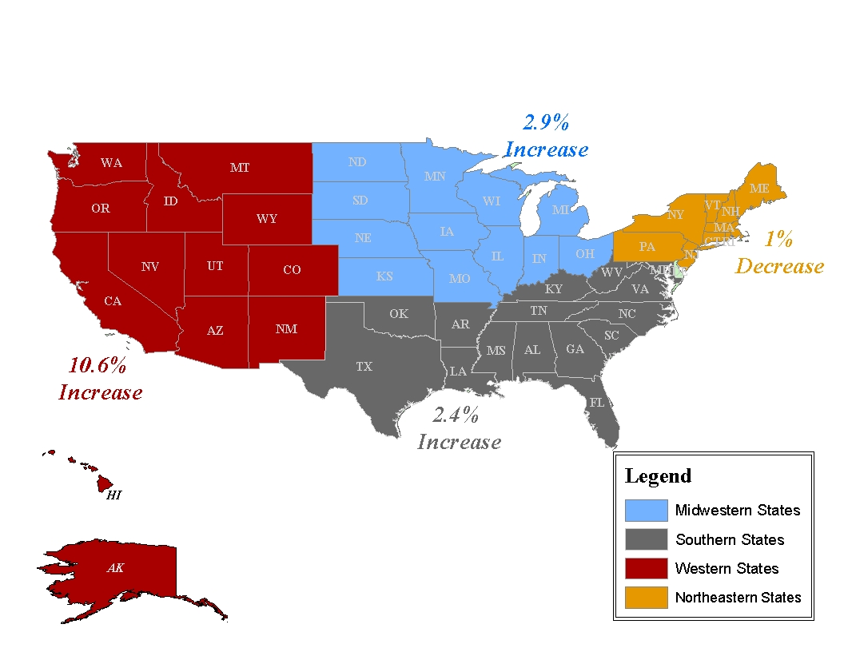

The Midwest is comprised of the following twelve states: Illinois, Indiana, Iowa, Kansas, Michigan, Minnesota, Missouri, Nebraska, North Dakota, Ohio, South Dakota, and Wisconsin. Since 1991, Illinois, Michigan, and Minnesota each implemented an ATPA in their state. Figure 4 shows the percent change in the vehicle theft rates in the Midwest States, from 1991 to 2001. Nine of the twelve states in the Midwest experienced a decrease in the vehicle theft rate during this time. Illinois experienced a 40 percent decrease, which was the largest decrease among the Midwest States. Three states experienced an increase in the vehicle theft rate from 1991 to 2001. The largest increase was in Nebraska (78 percent). The other two states with increases were Iowa (10 percent) and North Dakota (35 percent).

The vehicle theft rate increased in ten of the twelve Midwest States from 2000 to 2001. Illinois and Michigan were the only two states to experience a decrease from 2000 to 2001. Illinois’ vehicle theft rate decreased 3 percent and Michigan’s decreased 4 percent. The states with the greatest increases in their vehicle theft rate were Nebraska (24 percent) and Kansas (22 percent). The rates in the remaining states increased between .1 percent and 13 percent.

Figure 2:
% Change in Vehicle Theft Rate, 2000-2001
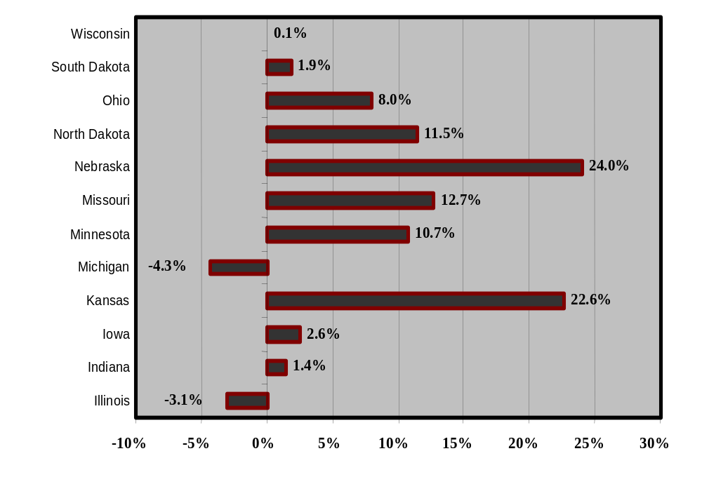

Motor Vehicle Theft in the State of Illinois

Illinois, covering an area of 56,400 square miles, is the 24th largest state in the nation in terms of area. With a population of 12,419,293 in 2000, Illinois is the 5th most populous state in the country. Extending approximately 385 miles from north to south and 218 miles across at its widest point, Illinois is a complex mixture of large urban population centers and vast rural areas. Eighty-eight percent of Illinois residents live in urban areas.

Illinois has a major population center home to more than half of the State’s 12.4 million residents. This population center includes the City of Chicago, Cook County, and the collar counties, DuPage, Kane, Lake, McHenry, and Will.

In the year 2000, the City of Chicago had 2,896,016 residents, nearly one-fourth of the statewide population. The City of Chicago is in Cook County that, in 2000, boasted a population of 5,376,741 residents. The five collar counties accounted for 2,714,979 additional residents. The remainder of the state accounted for 4,327,573 persons, or 35 percent of its total population, dispersed among 96 counties ranging in population from approximately 4,000 to 280,000 residents.

According to the U.S. Census Bureau, in the year 2000 73 percent of the state population was white, 15 percent was black, and the remainder was comprised of other racial groups. Twelve percent of all Illinois’ racial groups were ethnically Hispanic. Twenty-eight percent of Illinois residents were under the age of 18, and 49 percent were male.

Although the breakdown was not available for Illinois, in the United States in 2001, 31 percent of those arrested for auto theft were below the age of 18, 83 percent were male and 58 percent were white. Blacks and males are over-represented among those arrested for auto theft in the United States, although vehicle theft arrestees are increasingly older and more of them are female. Those arrested in Illinois for auto theft likely display a similar pattern to those found among vehicle theft arrestees in the United States, especially because the proportion of racial groups, males and females, and those under 18 are similar in Illinois and the United States.

The City of Chicago accounts for 23 percent of the State’s population, 14 percent of vehicle registrations and 86 percent of the state’s motor vehicle thefts. Suburban Cook County and Cook County as a whole had slightly larger percentages of vehicle registrations for trucks than was true for Chicago. Vehicle registrations in all counties in the state excluding Cook and the collar counties accounted for 20 percent of all registrations.

Eighty-three percent of state vehicle registrations are for automobiles, 15 percent are for trucks and 2 percent are for motorcycles. Although trucks comprise a small proportion of vehicle registrations, according to the Motor Vehicle Theft Intelligence Clearinghouse, five of the 10 most stolen vehicles in Illinois were trucks in both 2001 and 2002 (see Table 8 below). Despite this, automobiles are the most frequently stolen type of motor vehicle in the state and in the United States.

Table 6:
Motor Vehicle Registrations in Illinois, 2002
 | PASSENGER
AREA | CARS | TRUCKS | MOTORCYCLES | TOTAL
City of Chicago | 1,027,717 | 43,705 | 10,592 | 1,082,014
Suburban Cook | 411,839 | 77,475 | 11,273 | 500,587
Cook County | 1,439,556 | 121,180 | 21,865 | 1,582,601
DuPage | 562,725 | 58,179 | 9,796 | 630,700
Kane | 230,049 | 38,019 | 5,307 | 273,375
Lake | 367,173 | 46,213 | 7,690 | 421,076
McHenry | 151,550 | 29,311 | 5,207 | 186,068
Will | 234,035 | 43,815 | 6,180 | 284,030
Collar Counties | 1,545,532 | 215,537 | 34,180 | 1,795,249
State Minus Cook and Collar | 3,273,201 | 835,504 | 81,189 | 4,189,894
State Minus Cook | 4,818,733 | 1,051,041 | 115,369 | 5,985,143
State | 6,258,289 | 1,172,221 | 137,234 | 7,567,744
Source: Illinois Secretary of State

Table 7:
Percent of Motor Vehicle Registrations in Illinois by Vehicle Type, 2002
 | PASSENGER
AREA | CARS | TRUCKS | MOTORCYCLES
City of Chicago | 95% | 4% | 1%
Suburban Cook | 82% | 15% | 2%
Cook County | 91% | 8% | 1%
Collar Counties | 86% | 12% | 2%
State Minus Cook and Collar | 78% | 20% | 2%
State Minus Cook | 81% | 18% | 2%
State | 83% | 15% | 2%
Source: Illinois Secretary of State

Illinois ranked 21st for vehicle theft rates per 100,000 persons in 2001 when compared to the other states. This is lower than in past years: In 1999, Illinois ranked 16th and the state ranked 13th in 2000, as reported by the FBI. According to Crime in Illinois, the rate of motor vehicle thefts in Illinois steadily declined over time. Over the last ten years, from 1993 to 2002, the motor vehicle theft rate in Illinois declined 37 percent.

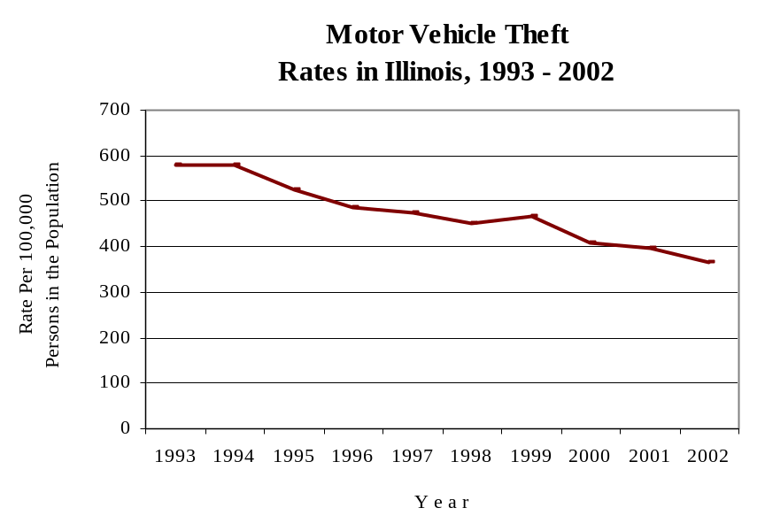
Figure 3:

Source: Illinois State Police, Crime in Illinois

In 2002, among trailers, all-terrain vehicles (ATVs) and Ford trucks, both the van and sport utility vehicle (SUV) versions, thefts of newer models were most common. All other vehicles on 2002’s top ten list were models dating from before 1994. In 2002, vehicles with the model year 1989 were the most frequently stolen.

Table 8:
Ten Most Stolen Vehicles
in Illinois, 2001 and 2002
2001 | 2002
Chevrolet Truck – Van | Chevrolet Truck - Van
Chevrolet Truck – SUV | Chevrolet Truck - SUV
Oldsmobile Cutlass | Oldsmobile Cutlass
Trailers | Trailers
Chevrolet Caprice | Toyota Camry
Toyota Camry | Chevrolet Caprice
Ford Truck – VAN | All-Terrain Vehicle
Ford Truck – SUV | Dodge Truck - Van
Chevrolet Truck - Pickup | Ford Truck - SUV
All-Terrain Vehicle | Ford Truck - VAN
Source: Motor Vehicle Theft Intelligence Clearinghouse

Approximately $327 million dollars in vehicles were stolen in Illinois during 2001. From 1991 to 2002, the Council funded about 30 vehicle theft programs in Illinois, spending approximately $66 million. It is important to note that during this time period, Council-funded programs saved $328 million in recovered stolen vehicles and reduced theft rates. From 1992 to 2002, Council-funded task forces recovered 7,024 stolen vehicles.
According to the Motor Vehicle Theft Intelligence Clearinghouse, in 2001 87 percent of stolen vehicles were recovered; this dropped to 81 percent in 2002. The number of recoveries of stolen motor vehicles decreases each year. However, this is perhaps due to the greater length of time available for recoveries for motor vehicle thefts from past years, and not to a real decline in the recovery rate.

In 2001, the average span of time between theft and recovery of a stolen motor vehicle was 26 days, compared to 17 days in 2002. In both 2001 and 2002 only 3 percent of stolen vehicles were recovered out-of-state, the remainder were recovered within the state. The overwhelming majority of recovered stolen motor vehicles were not damaged.

Figure 4:
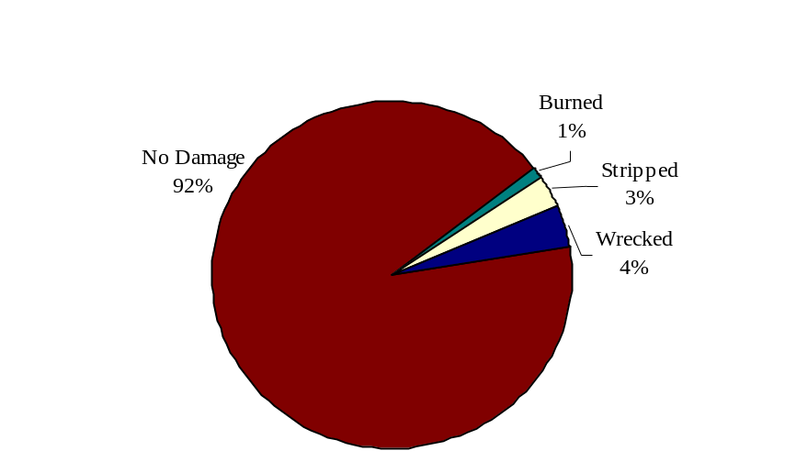
Conditions of Recovered Stolen Motor Vehicles in Illinois, 2002

Source: Motor Vehicle Theft Intelligence Clearinghouse

The conditions of recovered stolen motor vehicles may indicate the purpose for which the vehicle was stolen. For instance, a stripped vehicle was likely stolen for parts and a burned vehicle may suggest that the owner is attempting insurance fraud.

Of the 102,607 arrests reported to the FBI for vehicle theft in the United States in 2001, 10 percent were reported in Illinois (10,687 arrests). Arrests in Illinois for motor vehicle theft increased dramatically from 1991 to 2000 according to the FBI. In 1991, only 1,087 offenders were arrested for motor vehicle theft. During this time period, arrests for motor vehicle theft in the United States increased 19 percent.

In 2001, the average sentence length of the 803 offenders committed to the Illinois Department of Corrections for motor vehicle theft-related crimes was 4.2 years. Although the total number of motor vehicle theft sentences imposed in 2001 declined by 5 percent, the average sentence length increased from 4.0 to 4.2 years.

In 2001, as described in Crime in Illinois, 2001, motor vehicle thefts comprised 11 percent of all property crimes in Illinois; from 1997 to 2000, this proportion was similar.

Illinois Counties

The following 10 Illinois counties have the highest motor vehicle theft rates in the state: Cook, St. Clair, Winnebago, DuPage, Lake, Will, Madison, Peoria, Kane and Sangamon. All of these counties except for Madison experienced a decrease in the motor vehicle theft rate from 2001 to 2002. Council-funded motor vehicle theft task forces cover all of these counties except Sangamon and Lake.

Of the counties in Illinois covered by the motor vehicle theft task forces, only Winnebago and Boone counties experienced an increase in motor vehicle theft rates from 2001 to 2002. Boone County’s auto theft rate rose by 15 percent, and Winnebago County’s increased by 18 percent, during this time.

Table 9:
% Change in the Motor Vehicle Theft
Rate of Council-Funded Motor Vehicle
Theft Prevention Task Forces, 2001 to 2002
COUNTY | 2001 | 2002 | % CHANGE
Boone | 124.44 | 143.59 | 15%
Cook | 683.95 | 646.36 | -5%
DuPage | 105.51 | 92.79 | -12%
Grundy | 138.54 | 109.23 | -21%
Kane | 162.33 | 146.49 | -10%
Kankakee | 199.36 | 130.02 | -35%
Madison | 247.93 | 248.32 | 0%
Peoria | 391.97 | 344.54 | -12%
St. Clair | 672.05 | 493.2 | -27%
Will | 161.87 | 153.7 | -5%
Winnebago | 340.5 | 400.84 | 18%
Source: Motor Vehicle Theft Intelligence Clearinghouse

According to the Illinois State Police, Cook County accounted for three-fourths of all motor vehicle thefts in Illinois in 2001, and the City of Chicago accounted for 75 percent of thefts in Cook County. Thefts as far back as 1997 display a similar pattern.

Table 10:
Percentage of Statewide Motor
Vehicle Thefts by County Type, 2002
AREA | 2002
City of Chicago | 60%
Suburban Cook | 17%
Cook County Total | 77%
Collar Counties | 7%
Urban Counties | 12%
Rural Counties | 4%
Source: Illinois State Police, Crime in Illinois, 2001

Fifty-seven percent of Illinois counties not covered by motor vehicle theft prevention task forces experienced a decrease in auto theft from 2001 to 2002. Eight Illinois counties not served by task forces experienced a 100 percent or greater increase in motor vehicle theft from 2001 to 2001, Whiteside, Mercer, Henderson, Douglas, Scott, Hardin, Pope and Alexander (Figure 5).

Figure 5:
2001 - 2002 Increases in Motor Vehicle Theft Rates
in Illinois Counties Not Covered by Task Forces
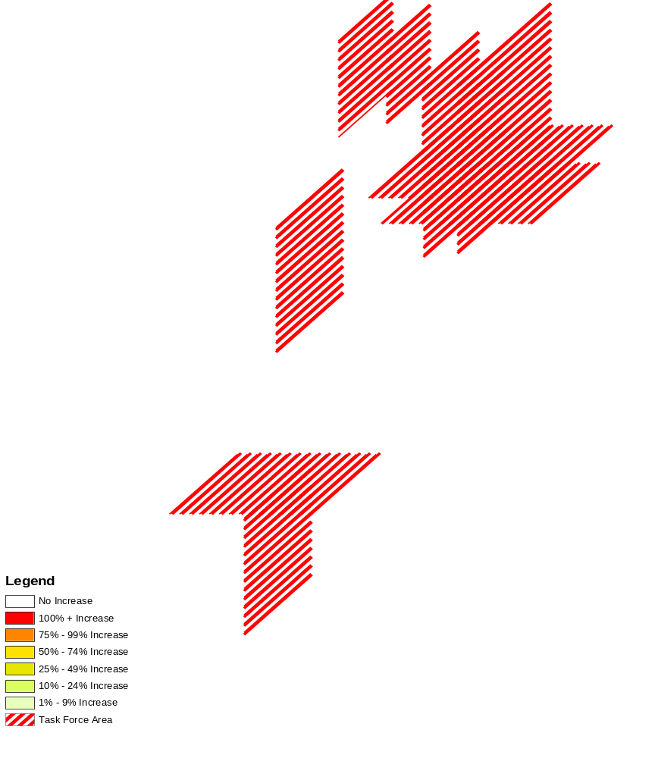

Source: Motor Vehicle Theft Intelligence Clearinghouse

According to the Motor Vehicle Theft Intelligence Clearinghouse, in 2002 Illinois counties recovered stolen vehicles in, on average, 68 percent of the cases. In that same year, counties covered by Council-funded task forces recovered an average of 74 percent of vehicles reported stolen. In 2002, Cook County’s recovery rate was 83 percent.

Illinois Cities

The City of Chicago has the highest number of motor vehicle thefts in the state. In 2002, motor vehicle thefts in Chicago comprised 60 percent of statewide vehicle thefts. Table 11 depicts the ten cities in Illinois with the highest motor vehicle theft rates in 2002, and the percentage that thefts in these cities comprise of the statewide total.

Table 11:
Ten Illinois Cities with the
Highest Motor Vehicle Thefts, and
Their Percentage of the State Total, 2002
CITY | PERCENT
Chicago | 86%
Rockford | 3%
Peoria | 2%
East St. Louis | 2%
Cicero | 2%
Harvey | 2%
Calumet City | 1%
Springfield | 1%
Joliet | 1%
Aurora | 1%
Source: Motor Vehicle Theft Intelligence Clearinghouse

Typically, cities with the highest motor vehicle theft rates also have the highest recovery rates. Table 12 lists the Illinois cities with the highest stolen motor vehicle recovery rates.

Table 12:
Ten Illinois Cities with the Highest
Stolen Motor Vehicle Thefts Recoveries, 2002
 | PERCENT
CITY | RECOVERED
Chicago | 84%
Rockford | 85%
Peoria | 91%
East St. Louis | 84%
Cicero | 81%
Harvey | 79%
Calumet City | 77%
Springfield | 93%
Joliet | 70%
Aurora | 78%
Source: Motor Vehicle Theft Intelligence Clearinghouse

All of the cities in Tables 11 and 12 are in areas covered by Council-funded task forces except the City of Springfield.

PART 3. INPUT ON THE COUNCIL’S STRATEGY
The following is a summary of input received during the development of previous strategies that is still considered relevant today, the input received from panelists and others, and the discussions that took place during the panel hearings.

Summary of Testimony and Recommendations from hearing

Vehicle theft in Illinois
- The data indicate motor vehicle theft in Chicago is a serious problem that drives the theft rate in the rest of the state.
- Generally, motor vehicle theft is about four times higher in those counties covered by task forces than those counties not served by task forces.
- The Council should work with the Secretary of State’s office to address problem areas in titling and registering heavy construction equipment; these vehicles should be registered with the state.
- The Council should investigate statutory language changes that would allow the use of statewide grand juries to investigate auto theft rings that cross county lines.
- The Council should investigate clarification of the language regarding information sharing in the existing statutes regarding immunity and the mandatory reporting of suspected insurance fraud.
- Multi-jurisdictional task forces with dedicated prosecutors have an impact on motor vehicle theft. The Council’s focus on areas of greatest need is still relevant and appropriate for future consideration.
- The task forces should increase communications with and work more closely with the SIU’s of insurance companies.
- Diffuse geographical areas experience different types of vehicle theft problems; there is no single solution that can be applied unilaterally across the state.
- Automobile theft rates are declining across the state but there are pockets where it is rising. The Council should work to identify layers of assistance to be provided to areas not covered by task forces. This could include: educational activities, public awareness, VIN etching and short-term projects with local law enforcement.

Recovery conditions
- Task forces are increasingly investigating farm equipment and construction equipment thefts. While the actual numbers of recoveries of these are low, each piece of equipment generally has a high value. The Illinois State Police Motor Vehicle Theft Intelligence Clearinghouse has and should continue to issue “Alerts” to the task forces as to how to identify construction equipment and to raise their awareness of these thefts.
- In 2002, 92 percent of recovered vehicles were recovered with no damage. Three percent were recovered stripped and one percent were recovered burned.
- In 2002, the average number of days for a vehicle to be recovered after it was stolen was 17 days.
- There is less focus on the quality of recovery data than on the data concerning reports of stolen vehicles; task forces want to know where the cars are being found. Unfortunately, 43 percent of the model fields in the LEADS database concerning vehicles recovered in 2002 were blank.
- Air bags are becoming a prime accessory for illicit vehicle parts. A new air bag that retails between $400 to $1,200 from a dealer costs between $50 to $100 on the illicit market.
- Approximately 19 percent of the 45,469 vehicles stolen in Illinois in 2002 were not recovered. Organized criminal elements involved in auto theft are suspected of exporting many of these vehicles. The top vehicle not recovered was the Chevrolet Truck-Van.

Data quality issues affecting auto theft
- Uniformity in motor vehicle data collection at a statewide level is of paramount importance. Efforts to utilize forms have improved.
- Computerized mapping and intelligence sharing through the Clearinghouse should continue to focus on auto theft trends, such as the discovery that the majority of cars stolen from DuPage County are recovered in Chicago, and many are found in gang territory on the city’s west side.
- Through geographical mapping, the locations of certain junkyards, streetlights, bushes, auto repair stores and other places are related to where vehicles have been stolen and recovered.
- The top eleven counties of motor vehicle theft include the areas where the Council has task forces, which supports their continued use in these locales.
- Although the accuracy of auto theft information being reported has increased, the Council should work to further improve the accuracy of the information.

Insurance Fraud
- The insurance industry reports that 10 percent of auto thefts are due to owner’s fraud. This figure represents individual owners who are experiencing financial difficulty or mechanical trouble with the vehicle and wish to report the car stolen, but are not the organized type of “give up,” which drives the rate to perhaps 25 percent. Organized “give-ups” occur when the owner of the vehicle voluntarily exchanges the vehicle for illegal drugs with a drug dealer. The drug dealer then operates the vehicle for a period of time and the owner later reports the car as stolen.
- The percentage of prosecutions of auto theft related fraud is low, approximately 5 percent of fraudulent claims, due to the difficulty in proving the fraud.
- Since a contributing cause to insurance fraud vehicle thefts is the ease of reporting a vehicle stolen to law enforcement, the Council should support in-person reporting if feasible. Vehicle owners who are claiming theft should have to sign a police document or report acknowledging the commission of a criminal act if found to have given false information.
- The task forces, Clearinghouse, task forces and National Insurance Crime Bureau, or NICB, and the insurance and allied industries are addressing and will continue to address the impact of insurance fraud. The NICB is a non-profit organization supported by approximately 1,000 insurance and self-insured companies dedicated to fighting insurance-related crime. A continued partnership between these allies will enable the statewide initiative to identify insurance fraud and apprehend offenders.
- The insurance industry should pass information of suspected owner “give ups,” where the vehicle owner disposes of the vehicle and files a claim for theft, along to the Council’s task forces. The industry should also give this information to the NICB. In turn, the task forces should give each suspected fraud serious attention.
- The auto theft task force directors have been successful in instilling in their officers the importance of looking at each auto theft case as a possible insurance fraud.
- Law enforcement would be greatly helped by information on multiple fraud claims made by single individuals. Linkage of insurance information systems to task force data would assist law enforcement greatly.
- The Council, task forces, Clearinghouse, and the NICB continue to work together with the insurance industry to raise insurer investigator awareness about Illinois reporting statutes. These statutes require insurance companies to report suspected motor vehicle fraud to a law enforcement agency. A legislative work group should be formed to discuss how to clarify which law enforcement agency is appropriate to report suspected fraud.
- There needs to be more emphasis on marking vehicle parts to trace their movements to assist law enforcement.
- The Council should seek to determine what percentage of vehicles reported as stolen is being submitted for insurance claims.

Carjacking/ Vehicular Hijacking
- Carjacking accounts for less than two percent of Illinois auto theft.
- The Federal Anti-Car Theft Act of 1992 (FACTA) makes carjacking a federal offense, punishable by up to life imprisonment. The 1994 Crime Bill increases the punishment for carjackers, calling for the death penalty when an innocent victim is killed.
- A carjacker is a different offender than the more typical auto thief, who is generally more sophisticated, has specialized knowledge and intelligence, but is usually non-violent. These offenders are violent and dangerous and must continue to be vigorously prosecuted by prosecution task forces.
- According to the Cook County State’s Attorney’s Office, carjackers seek money quickly, are not opposed to using violence, roam around looking for someone to victimize, and often need money to pay for drugs. Judges are inclined to give the maximum penalty and disinclined to plea bargain these cases.
- Self-service gas stations and convenience stores are prime targets for carjackers. The public needs to be made aware of this trend and to take measures, such as getting gas during the day and in well-lighted areas.
- As auto thieves have been forced to come up with new ways to steal cars due to better security devices like smart keys, vehicular hijacking continues to be an extremely dangerous problem in Cook County.
- During 2002 there were 1,372 vehicular hijacking and aggravated vehicular hijacking cases were reported in Chicago. That same year the Chicago Police were able to arrest 209 offenders. During the same year the Cook County State’s Attorney’s office prosecuted over 291 aggravated vehicular highjacking and vehicular high jacking cases which were initiated in the city and the suburbs.

Juveniles
- Youth who commit auto theft offenses are frequently connected with gangs and are in the criminal “breeding area” for long-term offenders.
- Vehicle theft by juveniles is on the rise in Illinois and in neighboring states, as indicated by arrest data.
- Youth steal cars for; 1) immediate gratification; 2) profitability obtained by selling the car to a drug dealer or a chop-shop; 3) excitement of being at risk of being caught; 4) status and prestige the juvenile experienced with peers and in the neighborhood; and 5) gang initiation. It was recommended that these factors be taken into account in refining Council-funded prevention and law enforcement initiatives.
- It was recommended that juveniles who commit three or more motor vehicle offenses be sentenced to IDOC.
- Youthful offenders would benefit from concentrating some public relations efforts aimed at helping them understand how auto theft victimizes real people.

Prosecution
- The firm partnership established between motor vehicle theft task forces and prosecution personnel should be continued.
- The best way to prosecute insurance fraud is through an admission from an offender. Consensual overhears recorded of such admissions usually result in pleas of guilty, thus such court-ordered consensual overhears should be considered more frequently for use in auto theft cases.
- It is sometimes difficult for prosecutors to deconstruct complex auto theft cases for a judge and/or jury due to the tangled scams certain defrauders use. Technology could be very helpful to them in clarifying the issues; the use of audio/visual aids, courtroom computers and large screens should be supported by the Council if funds become available.
- Tactical support by staff from the Motor Vehicle Theft Intelligence Clearinghouse results in the completion of analytical products, which assists with case organization, reveals conspiracies and leads to ultimately successful convictions.

Recycling and salvage industries

- Tracking of used essential parts should be done to prevent unscrupulous recyclers, rebuilders, and repairers from selling and or using stolen/illegal parts.
- The tracking of salvage titled vehicles sold at salvage auto auctions, especially those that are determined to be “unprofitable” to repair, flood vehicles, high theft vehicles and total burn vehicles to dealers both in state, out of state, and those exported.
- By monitoring and reviewing in accordance to state mandated rules and regulations coupled with special police programs will assist “licensed” vehicle related businesses to combat the perception by the public and other organizations of being unscrupulous by dealing in stolen/illegal vehicles and parts.
- Reducing the number of vehicles that have had the vehicle identification numbers removed and or destroyed by damage, fire, or individual error will result in less opportunity for vehicle re-tagging.
- Establish an advisory committee consisting of representatives of the insurance industry, recycling/salvage industry, and the Secretary of State to determine and define a uniform identification process between salvage and junk titled vehicles.
- Establish public recognition / information on licensed dealers that have met state guidelines in the operation of their business.
- Establish a legislative committee of the “industry” and the Secretary of State to review and recommend changes to the rules and regulations governing the industry.
- Identify to the public consumer those vehicles that have been previously salvage and flood vehicles through title identification and communication.
- Participate in multi-jurisdictional inspections to identify potential stolen cars and parts.
- Reverse role operations have been successfully employed in other states. These operations not only identified illegal activities but allowed public officials the opportunity to commend legitimate business owners who refuse to accept the stolen goods.

Public awareness
- The National Insurance Crime Bureau (NICB) has developed a “layered approach” encouraging motorists to “layer” their vehicle with an appropriate degree of anti-theft protection based on factors such as the popularity of the vehicle for theft, value of the vehicle, and the vehicle’s location. The Council should reinforce this message in its own public awareness activities and publications and support the NICB’s efforts wherever possible.
- The council should encourage public awareness efforts that encourage theft prevention techniques such as VIN etching, the use of audible alarm and steering wheel incapacitation systems, etc.
- Networking with insurance companies and other state agencies to distribute public information messages should be implemented.

Motor vehicle theft investigation training
- The 8 and 32 hour training courses were identified as good tools to educate local law enforcement. The 90-day temporary assignment of local law enforcement to task forces has also proven to be successful. Prosecutors clearly indicated that trained officers prepare better cases for prosecution. Finally, industry investigators and task force directors identified the need for advanced training for auto theft investigators.
- Chiefs and Sheriffs are in favor of continued statewide officer training in motor vehicle theft investigation. In a previously conducted survey, they responded that officers attending vehicle theft training asked more and better questions and were checking for patterns in theft they previously had not. They also were reported to have increased their skills and techniques for discovering false theft claims and insurance fraud as well as a better understanding of transportation theft, parts theft, VIN switching and retagging.
- Roll call training should be used to advise all police officers of insurance fraud indicators.
- The Council should continue to support the training courses currently offered statewide by the Illinois State Police, such as the regional in-service training seminars for patrol officers and for experienced auto theft investigators. Emphasis on interview and interrogation techniques; construction equipment and specialty vehicle theft investigation was recommended.
- It was strongly suggested that the auto theft investigator training curriculum include cross-training due to the interrelationship between auto theft and other criminal activity as well as in-depth training on the types of offenders: career, juvenile, gang member, drug user/dealer.

Theft by fraud
- Auto thieves have adapted their methods because automobile manufacturers have made it more difficult to steal cars. The use of technology as a tool to facilitate auto theft is increasing. Fraudulent key cuts and counterfeit cashier’s checks are two examples of issues discussed by panelists.
- Organized criminal elements continue to be involved in auto theft. Emphasis should be placed on their involvement in the export, re-tagging and cloning of stolen vehicles.
- Criminals involved with identity theft are a growing problem as they use the victim’s identity to steal automobiles. Some efforts may need to be made for increased enforcement, prosecution, and training concerning this evolution of criminal activity.
- Criminals involved with identify theft usually obtain drivers’ licenses and other documents with the names of victims who have a good credit history. They then target dealerships that promote “no money down”, “low financing” and other sales incentives.
- The false information provided to the dealerships inhibits law enforcement in effectively investigating the theft of the vehicle.
- The Council should decide what role the task forces should play in combating identity theft. While an individual’s credit rating is always adversely affected by this crime another gravely impacted victim in any identity theft is the product’s seller, (usually an automobile dealer) and the financial entity that secured the purchase. The question to be answered by the Council is whether these victims are within the purview of the council’s mission statement. Auto theft caused by stolen identity is only a facet of the theft scheme but is readily discernible because of the extensive VIN record keeping indigenous to automobile manufacturing. The Council should consider whether automobile identity theft prosecution is more appropriate in a specialized task force that includes financial institutions, automobile dealers and merchandise retailers or pursued separately by the task forces alone.

Conclusion

Motor vehicle theft is a complex problem. This chapter described the types of motor vehicle theft, and gave an overview of motor vehicle theft in the United States and regions within the United States. Also covered was the character of vehicle theft in Illinois, and in individual Illinois counties and cities. Below are highlights from each of the sections in this chapter.

The United States:

- Between 1991 and 2001, motor vehicle theft rate in the United States decreased 35 percent, whereas during the same time period, the vehicle theft rate in Illinois decreased 40 percent.
- In the United States, motor vehicle theft is the most costly and most commonly reported property crime.
- Motor vehicle thefts comprise 12 percent of all property crimes in the United States.
- Nine of every 1,000 households in the United States were victims of motor vehicle theft. Eight of every 1,000 white households, 16 of every 1,000 black households and 20 of every 1,000 Hispanic households were victims of motor vehicle theft in 2001.
- The United States had a 62 percent stolen motor vehicle recovery rate in 2001.
- Blacks and males are over-represented among those arrested for motor vehicle theft compared to the proportion of the population at large these groups comprise.
- Since 1991, those arrested for motor vehicle theft in the United States are older and more are female.

Regions of the United States:

- States and cities in the western portion of the United States are currently experiencing particularly high levels of motor vehicle theft.
- Illinois and Michigan were the only states in the Midwest to experience a decrease in their motor vehicle theft rate from 2000 to 2001.

The state of Illinois and counties and cities in Illinois:

- Illinois ranked 21st in motor vehicle theft rates among states in the nation.
- Five of the ten most stolen vehicles in Illinois were trucks.
- $327 million in vehicles were stolen in Illinois in 2001.
- From 1991 to 2002, the Council spent $66 million combating motor vehicle theft in Illinois, and saved $328 million in recovered vehicles and other auto theft-related costs during the same time period.
- In Illinois in 2002, 81percent of stolen vehicles were recovered, and 92 percent were undamaged.
- Winnebago and Boone counties were the only ones covered by auto theft task forces to experience an increase in motor vehicle theft from 2001 to 2002.
- Eight counties in Illinois had a 100 percent or greater increase in motor vehicle theft rates from 2001 to 2002.
- Cook County accounts for 75 percent of auto thefts in Illinois, and Chicago accounts for three-fourths of vehicle thefts in Cook County.
- Chicago accounted for 60 percent of motor vehicle thefts in the state in 2002.
- Illinois counties with motor vehicle theft prevention task forces had an average recovery rate of stolen motor vehicles of 74 percent in 2002. The state’s recovery rate that year was 68 percent, while Cook County’s recovery rate was 83 percent.
- Cities with the highest theft rates also experience the highest rates of recovery. In the year 2002, the ten cities with the highest recovery rates in Illinois were all covered by a Council-funded task force except for the City of Springfield.

PART 4 Response to Motor Vehicle Theft in Illinois

Through the Council, motor vehicle theft in Illinois has been combated through enforcement, prosecution, training, research and analysis and auditing. The following is a description of Council-funded programs in Illinois and a list of each program’s accomplishments in 2002.

DuPage County Auto Theft Task Force

The DuPage County Auto Theft Task Force, known as BATTLE (Beat Auto Theft Through Law Enforcement), operates in DuPage County, located in northeastern Illinois. In a coordinated effort to identify and arrest offenders, the officers work with numerous agencies, such as local Crime Stoppers programs, insurance companies, and local, county, and federal police agencies. In 2002, BATTLE conducted 106 investigations resulting in 118 arrests, of which 110 were referred for prosecution. The work of the task force led to 42 convictions in 2002. BATTLE also recovered 66 stolen vehicles worth an estimated $646,762.

Kane County Auto Theft Task Force

The Kane County Auto Theft Task Force (KCAT) serves the Kane County area located in northeast Illinois. The unit’s central activities include intelligence gathering, surveillance, and monitoring areas prone to vehicle thefts. In 2002, KCAT carried out 76 investigations that resulted in 97 arrests. The task force referred 68 cases for prosecution that led to 46 convictions in 2002. In addition, the task force recovered 82 vehicles worth an estimated $1,065,092.

Metro-East Auto Theft Task Force

The Metro East Auto Theft Task Force operates in Madison and St. Clair Counties located in southern Illinois. The task force combats vehicle theft by working closely with the police departments of St. Louis and St. Louis County. In 2002, the Metro East Auto Theft Task Force conducted 589 investigations and made 290 arrests. All 290 cases were referred for prosecution and 77 resulted in convictions. The unit recovered 282 vehicles worth an estimated $2,048,257. In a collective effort with the MV Training Program, the task force also conducted several motor vehicle theft trainings for investigators and patrol officers in 2002.

Northern Illinois Auto Theft Task Force
The Northern Illinois Task Force covers Winnebago and Boone Counties. In 2002, the Northern Illinois Auto Theft Task Force launched 303 investigations, resulting in 114 arrests. The work of the task force officers resulted in 66 convictions in 2002. The task force also recovered 307 stolen vehicles worth an estimated $1,995,707.

State and Local Auto Theft Enforcement Task Force

The State and Local Auto Theft Enforcement Task Force (SLATE) serves Peoria County in the central region of Illinois. During 2002, the program’s third year of operation, SLATE conducted 283 investigations and made 238 arrests. The task force referred 233 of these cases for prosecution, resulting in 83 convictions. In addition, the task force recovered 139 vehicles worth an estimated $917,643. In a cooperative partnership with the Council’s Training Program, the task force officers instructed five motor vehicle theft trainings for investigators and patrol officers in 2002. In addition, the officers conducted roll call training for local law enforcement agencies in Peoria County. SLATE officers also participated in neighborhood watch programs and instructed at the Peoria Police Citizen Academy.

South Suburban Auto Theft Interdiction Network

The South Suburban Auto Theft Interdiction Network (SSATIN) serves the south and west suburban Cook County metropolitan area. In 2002, SSATIN conducted 204 investigations that resulted in 219 arrests, of which 170 were referred for prosecution. The work of the task force led to 58 convictions in 2002. The unit recovered 296 stolen vehicles worth an estimated $4,791,395. In 2002, the SSATIN program provided nine roll-call trainings for law enforcement officers at four Chicago Police Districts and the Glenwood Police Department. Two officers participated in the 120-day temporary assignment program, which allows a law enforcement agency to assign an officer to SSATIN in order to learn methods of identifying stolen vehicles, schemes, interview techniques, report writing, and case preparation. To increase public awareness, SSATIN conducted three VIN etchings for 150 citizens. The task force also held three vehicle theft training sessions for financial lending officers from local banks, owners and managers of local car dealerships, and members of the Chicago Metropolitan Car Dealerships Association.

Tri-County Auto Theft Task Force

The Tri-County Task Force serves the Joliet area, including Will, Kankakee, and Grundy Counties. The task force links the efforts of the Illinois State Police, the sheriff’s offices of Will, Grundy, and Kankakee Counties, and the police departments of Joliet, Bolingbrook, Romeoville, and Kankakee City. In 2002, the task force performed 263 investigations that resulted in 106 arrests. All 106 cases were referred for prosecution, resulting in 39 convictions. The unit recovered 222 vehicles that were worth an estimated $2,012,560. In 2002, the Tri-County Task Force sponsored eight intelligence meetings with local law enforcement agencies. The officers conducted several VIN etchings and made presentations for local citizen police academies, the Kankakee County auxiliary police officers, and local high schools. Several task force officers also presented at the American Trucking Association Loss Prevention Seminars in Chicago and Texas. The work of the task force was recognized by the International Association of Auto Theft Investigators (IAATI), which granted the task force a Certificate of Merit Award in 2002.

Cook County Motor Vehicle Theft Prosecution Unit

The unit is comprised of one supervising and three specially trained prosecutors, two state’s attorney’s investigators, an administrative assistant, and two part-time law clerks. The four senior attorneys prosecute career auto thieves as well as individuals involved in chop shop operations, insurance fraud, organized street gang operations, carjacking, and the illegal activities of rebuilders and scrap dealers. The prosecution team ‘vertically’ prosecutes targeted vehicle theft cases and related crimes in Cook County. In vertical prosecution an attorney is assigned a case from submission through trial, a method considered critical for prosecuting vehicle theft cases. Two Cook County State’s Attorney’s investigators augment police work by tracking documents, locating witnesses, and conducting detailed background investigations.

In 2002, 170 vehicle theft-related cases were referred for prosecution. The work of the prosecution unit led to 126 indictments of 170 defendants. There were 214 cases that received sentencing in 2002 (which include some cases initiated in 2000 and 2001). The cases resulted in 130 guilty pleas and 26 findings of guilt. Ninety-two defendants were sentenced to prison or jail and 34 received felony probation. The remaining defendants received lesser sentences or were found not guilty. Restitution and court costs totaling $170,319 were also ordered.

Secretary of State Special Audit Teams Program

The Secretary of State Special Audit Teams Program focuses on policing the “marketplace” for stolen vehicles and parts using special audit teams. There were four teams in operation during 2002, which were located in Chicago, Rockford, Peoria, and East St. Louis. The teams travel throughout Illinois, monitoring salvage yards, rebuilders, repairers, insurance pools, and scrap processors for compliance with regulations governing record keeping of vehicle and vehicle part transactions. The teams are comprised of 14 auditors and four supervisors, as well as 8 clerical personnel, and are supervised by 4 administrators.

In 2002, the teams performed 2,802 audits involving 40,223 vehicles and 2,227 essential vehicle parts. In all, 88 stolen vehicles and 200 contraband (illegally imported) vehicles were recovered, for a total estimated value of $2.4 million. There were 21 essential vehicle parts recovered, worth an estimated $46,400. The teams also inspected 3,166 certificates of title, 20,771 junk certificates, and 2,973 salvage certificates. There were 397 violation letters issued, which resulted in 796 charges.

Insurance Vehicle Expense Fund Program

To support Council-funded law enforcement efforts, insurance companies have loaned vehicles for use by Council-funded programs. To date, 29 different insurance companies have loaned 300 vehicles. The vast majority of these vehicles are recovered stolen vehicles obtained from the insurance salvage pools in the Chicago metropolitan area. Program funds are used to repair these vehicles as well as to obtain required Illinois titles and license plates. The Council, through the Illinois Anti-Car Theft Committee, has designated trust funds for repairing or purchasing parts for these vehicles to make them safe for operation by the task forces. The task force officers are assigned these vehicles for surveillance and undercover activities.

Funds that would have been used to purchase or lease new vehicles at a much higher cost are being used instead to fund other grant expenses. In 2002, Council-funded programs received 74 vehicles from insurance companies. If the Council had leased these vehicles, the estimated cost for the year would have been approximately $374,000. These savings allowed for expenditures from the fund to total approximately $17,510. The cost of licensing and registering vehicles was $2,409 in 2002.

Motor Vehicle Theft Intelligence Clearinghouse

The Motor Vehicle Theft Intelligence Clearinghouse provides focused statewide analytical support for motor vehicle theft task forces and the Illinois law enforcement community. The unit consists of three criminal intelligence analysts and one clerical personnel, and is directed by a master sergeant assigned by the Illinois State Police. The Clearinghouse annually publishes the “Illinois Motor Vehicle Theft Statewide Assessment,” which includes theft and recovery trends, theft rates by county, and a geographic analysis of the motor vehicle theft problem during the previous year. The report is distributed to the Council-funded task forces, the Council, and the Illinois State Police Training Academy. The Clearinghouse also develops the “Motor Vehicle Theft Task Force Quarterly Activity Summary,” which provides information to the Council and Grant Review Committee on the performance of Council-funded task forces.

During 2002, the Clearinghouse received 349 requests for information, crime analysis, mapping, charting, case assistance, and the production of strategic and tactical products. These requests included 262 inquiries from the Council-funded auto theft task forces, 32 from the Illinois State Police, 13 from federal agencies, 17 from local law enforcement, and 25 from other criminal justice entities.

Motor Vehicle Theft Investigation Training Program

The Motor Vehicle Theft Investigation Training Program is administered by the Illinois State Police. The goal of the program is to increase awareness and understanding of motor vehicle theft among the law enforcement community and the insurance industry in Illinois. The program offers classes for investigators, patrol officers, and insurance industry officials. The training classes cover important characteristics of vehicle theft cases and investigation techniques specific to vehicle theft related cases.

In 2002, the program conducted six, 36-hour courses, targeting Council-funded vehicle theft task forces. Seventy-four officers attended the investigator training classes. The program also conducted sixteen, 8-hour training classes for patrol officers. Two hundred and ninety-one officers attended 8-hour classes in 2002. The training evaluation forms completed by the participants and instructors reported favorable assessments of the training classes.

The Council’s 2002 achievements:

18,155 criminal investigations initiated
28,943 audits of vehicle-related businesses
23,896 stolen vehicles recovered worth nearly $155 million
9,500 violation letters issued to audited businesses
9,216 persons arrested
3,370 convictions obtained

PART 5. THE COUNCIL’S FUNDING STRATEGY

Priority problem areas

Based upon public hearing testimony, successful activities from previous strategies, analyses of available data, and the remarks made during the two-day panel discussions in May 2003, the Council identified the following priority problem areas that should be addressed by its 2004-2007 Statewide Motor Vehicle Theft Prevention Strategy. Important in the development of these priority problem areas is the transfer of funds from the Motor Vehicle Theft Prevention Trust Fund to the state General Fund to help balance the budget. The transfer of these funds will significantly limit the ability of the Council to expand program areas and projects, and most likely require a reduction in some of the programs.

Limited law enforcement resources
The criminal justice system should respond to vehicle theft and related crimes in a coordinated fashion. Multi-jurisdictional task forces are needed to be the backbone of the Council’s strategy in this regard combining investigative and prosecutorial resources.
Motor vehicle theft operations continue to typically encompass a number of law enforcement jurisdictions, and, therefore, the law enforcement response should likewise be multi-jurisdictional in nature. Multi-jurisdictional approaches are recommended as a way to maximize limited law enforcement resources. Limited resources mean there is a lack of specialized equipment. Lack of fiscal resources means lengthy or involved investigations cannot be supported.
Most law enforcement agencies do not have the manpower to devote to motor vehicle theft cases and, generally speaking, unless someone is apprehended in a stolen vehicle, most departments spend little time investigating motor vehicle thefts.
The drain on resources caused by drug and gang problems facing many communities adversely affects anti-vehicle theft efforts. Individual law enforcement agencies are not adequately equipped or staffed to implement sustained, organized enforcement efforts. Multi-agency cooperation and investigative teams improve both the rate of thefts and the recovery of stolen vehicles.
Limited local resources translate into a need for a task force approach to the problem. Task forces reduce jurisdictional constraints and adapt easily when site of theft differs from site of recovery, can follow offenders across many small jurisdictions, are more knowledgeable about violations than local departments, and can coordinate investigations across jurisdictions.
Although auto theft may be going down in some areas of the state, other areas have seen a dramatic increase. Motor vehicle theft task forces need to identify layers of assistance they may be able to provide to those areas not covered by the task force and offer assistance in dealing with the motor theft problem. This assistance could include but is not limited to VIN etching, public information/education displays, and working with local law enforcement on short-term projects.
Organized criminal elements continue to be involved in auto theft. Motor vehicle theft prevention operations should emphasize activities that focus on the exporting of locally stolen vehicles, re-tagging and cloning operations.
A majority of task force operations should focus on the theft of passenger type vehicles. The Council recognizes that the investigation of the theft of construction equipment, ATV’s etc. will be requested. As long as a minimum of 60 percent of investigative time is spent on the investigation of the theft of passenger vehicles, the investigation of other types of theft is acceptable.

The rising cost of programs compared to the fixed assessment of funds and required state subsidies
Vehicle theft is a social, economic problem affecting motorists, law enforcement, insurers, motor vehicle administrators, vehicle manufacturers, customs, and taxes—in short, all citizens. The broad-based comprehensive and conservative funding approach taken by the Council is appropriate and should, to the extent feasible, be continued.
Faced with grant funds that are tied to the $1 assessment, and in light of the transfer of well over $4.5 million from the Motor Vehicle Theft Prevention Trust Fund to that of the state General fund, in the last two years, a most conservative approach to program funding must be adhered to during the next four years of Council activities. It will be incumbent on program directors of units seeking Council funding for operations over the next four years to be innovative, resourceful and fiscally conservative.
Insurance company payments into the Trust Fund are based on the definition of the term “motor vehicle” rule that only includs private passenger vehicles and some pick-up trucks. Although task force directors have been given some latitude in investigating other vehicle related thefts, the main focus of activities remains that of “motor vehicle” theft.
For 2004-2007, the amount of funds expected to be available for programs will be about $5.9 million per year. Without a conservative approach to the funding of projects, at current funding levels, deficits in the millions of dollars can be expected. The Council can’t operate with a deficit; therefore it simply must plan to spend less. Attempts by Council staff and unit directors to identify alternate sources of funding must be emphasized as part of the statewide strategy during the next four years.

Criminal prosecutions
Public input indicated that motor vehicle theft cases could be extremely complex involving sophisticated schemes and vehicle identification issues. Hence, criminal prosecution is difficult. Vertical prosecution is an effective method of handling auto theft and insurance fraud cases, particularly those of a complex nature. Task force efforts are benefited greatly by the inclusion of state’s attorneys in their investigative work. The stronger the link to the prosecutor’s office, the more effective the task forces have been.

Motor vehicle theft enterprises in some areas of the State involve some dealers of vehicles, parts, and scrap
Some dealers of vehicles, parts, and scrap are involved in the motor vehicle theft problem. Even some reputable dealers may sometimes purchase and use essential parts removed from stolen vehicles. Retagging operations/thefts of whole vehicles are generally very organized and sophisticated operations. Used vehicle dealers can be outlets for profitable retagging operations.
Council-supported programs should strive to target the receivers of stolen vehicles and parts and to target the marketplace for contraband. Coordinated efforts between motor vehicle theft task forces and special investigations units should be undertaken to employ innovative means such as reverse roll “stings” in identifying and arresting perpetrators of these type crimes. Attempts should also be made to provide some type of recognition for businesses that refuse to purchase stolen parts during reverse role operations.
Historically, many vehicles were stolen in order to remove major external parts and sell them to salvage yards or repair shops. When good quality recycled parts are available, the demand for stolen parts decreases. Increasingly, vehicles are stolen and stripped only for valuable accessories such as seats, expensive radios, wheels, air bags, and electronic components.
The Federal Anti-Car Theft Act of 1992 (FACTA) expanded vehicle part markings to include all vehicle make and models by the end of 1997. The Act also requires repair shops, insurers, recyclers and dismantlers handling a used part to check the part’s VIN against a national vehicle database.
If possible, legislative efforts at increasing the severity for violations of existing statutes regarding salvage parts and scrap dealers should be pursued by the Council.

Insurance Fraud and Theft by Fraud
It should be perfectly clear that there is a difference between insurance fraud, and theft by fraud. Although fraud may be utilized in various aspects of insurance claims, a trend that is becoming quite prevalent in the state is the theft of items by fraud, including identity theft.

The insurance industry estimates that ten percent of reported stolen vehicles are fraudulent claims. The Council was told that using “fraud indicators”, insurance fraud is probably closer to 25 percent in some parts of the country. This figure is derived from a combination of factors which include the presence of fraud “indicators” in the insurance claim, recovered vehicles which display conditions other than a normal theft (e.g. keys in ignition, no damage to critical areas of the vehicle, etc.), and arrests for and admissions to committing fraud.
Vehicle owners continue to be involved in vehicle thefts, conspiring to defraud insurance companies. Owner involvement in fraudulent activities has become increasingly widespread. Owners plot the disappearance or destruction of their vehicle: a) to receive an insurance settlement; b) to end car payments; c) to end repair bills; d) to avoid selling a vehicle; and/or e) to break a restrictive car lease or f) as part of a “give up” related to a drug sale.
The insurance industry recognizes that the tremendous cost of insurance fraud has had a profound effect on the affordability of automobile insurance. Illinois insurers have taken several initiatives including: a) formation of and increased staffing of special investigative units; b) continuous education and training of all insurance company personnel in the recognition and resistance of fraudulent claims; c) increased public awareness activities designed to educate the public on the direct effect that insurance fraud has on insurance premiums; and, d) offering premium discounts to policyholders who install anti-theft devices on their vehicles.
The sharing of information between law enforcement and the insurance industry has been improved, yet more can be done. Illinois has insurance fraud reporting and immunity laws but many company employees are not aware of these laws and are reluctant to release claim file information unless ordered to do so by subpoena. Insurance companies can improve the release of claim file materials to law enforcement by educating their own employees on these statutes.
Support and outreach between the task forces and the insurance industry has been improved, resulting in a better understanding of the unfamiliar issues, assistance with the extra workload, and clarification of public perception issues connected with financial crimes. The Council should continue to support task force officers and insurance investigators joining each other’s associations as well as cross-training and networking aimed at improving the lines of communication between law enforcement and the insurance industry.

Identity Theft
Identity theft and identity fraud are terms used to refer to all types of crime in which someone wrongfully obtains and uses another person's personal data in some way that involves fraud or deception, typically for economic gain. Many people have reported that unauthorized persons have taken funds out of their bank or financial accounts, or, in the worst cases, taken over their identities altogether, running up vast debts and committing crimes while using the victims' names. In many cases, a victim's losses may include not only out-of-pocket financial losses, but also substantial additional financial costs associated with trying to restore his reputation in the community and correcting erroneous information for which the criminal is responsible.
With enough identifying information about an individual, a criminal can take over that individual's identity to conduct a wide range of crimes: for example, false applications for loans and credit cards, fraudulent withdrawals from bank accounts, fraudulent use of telephone calling cards, or obtaining other goods or privileges which the criminal might be denied if he were to use his real name. If the criminal takes steps to ensure that bills for the falsely obtained credit cards, or bank statements showing the unauthorized withdrawals, are sent to an address other than the victim's, the victim may not become aware of what is happing until the criminal has already inflicted substantial damage on the victim's assets, credit, and reputation.
The Department of Justice prosecutes cases of identity theft and fraud under a variety of federal statutes. In the fall of 1998, for example, Congress passed the Identity Theft and Assumption Deterrence Act. This legislation created a new offense of identity theft, which prohibits
knowingly transfer[ring] or us[ing], without lawful authority, a means of identification of another person with the intent to commit, or to aid or abet, any unlawful activity that constitutes a violation of Federal law, or that constitutes a felony under any applicable State or local law.
18 U.S.C. § 1028(a)(7). This offense, in most circumstances, carries a maximum term of 15 years' imprisonment, a fine, and criminal forfeiture of any personal property used or intended to be used to commit the offense.
Schemes to commit identity theft or fraud may also involve violations of other statutes such as identification fraud (18 U.S.C. § 1028), credit card fraud (18 U.S.C. § 1029), computer fraud (18 U.S.C. § 1030), mail fraud (18 U.S.C. § 1341), wire fraud (18 U.S.C. § 1343), or financial institution fraud (18 U.S.C. § 1344). Each of these federal offenses are felonies that carry substantial penalties in some cases, as high as 30 years' imprisonment, fines, and criminal forfeiture.
Under existing Illinois’ law, 720 ILCS 5/16G-15 a person commits the offense of Financial identity theft when he or she knowingly uses any personal identifying information or personal identification document of another person to fraudulently obtain credit, money, goods, services, or other property.
Recent legislation passed by both Illinois Houses and pending the Governor’s signature will allow identity (ID) theft victims the ability to file and receive a report as well as initiate an investigation with their local law enforcement agency, regardless of where the actual theft of their information may have occurred. This is important because frequently ID theft victims frequently have no knowledge of where the theft of their information occurred. Victims will be able to obtain a certified court order declaring their innocence of the unlawful conduct committed by a criminal using their identifying information. This will allow victims to avoid arrest and detention for crimes committed by someone else as well as provide a means to clarify their criminal record with various entities such as potential employers who might screen applicants on this basis.

The collection, analysis, accuracy, completeness and sharing of vehicle theft statistical data and criminal intelligence data
Accurate statistical data concerning motor vehicle theft continues to be of critical importance for the Council’s program for two reasons. First of all, these data are required to assess the need for and impact of motor vehicle theft reduction programs. Secondly, this information is required to evaluate the effectiveness of the Council’s statewide strategy.
One of the continuing concerns with current UCR and LEADS data is that, for evaluation purposes, it is dependent on the consistency of reporting practices from one law enforcement agency to the next. For example, one agency may count an entire vehicle as “recovered” if one major part of the vehicle is recovered. Another may score a recovery if the majority of the car is recovered. A third agency may record a recovery based on whether major parts were recovered.
The Illinois Motor Vehicle Theft Intelligence Clearinghouse is an important resource for motor vehicle theft data collection and dissemination in the state and should continue to be supported by the Council.

Training of law enforcement, prosecutorial agencies, and others combating vehicle theft
The area of training continues to be cited as a recommended focus for Council programs.
Patrol officers and investigators continue to need statewide training on stolen vehicle recognition.
Training in advanced vehicle theft investigations for experienced vehicle theft investigators should be implemented.
The training of insurance industry representatives in the area of theft detection, investigation, and prevention is also a need that should be addressed.
Training topics that should be covered are:
- laws governing vehicle theft, types of thefts and the trends governing them;
- how to recognize stolen vehicles;
- investigation of occupied vehicles;
- modus operandi of the vehicle thief;
- vehicle identification numbers, sources of information;
- preliminary investigation subsequent to the recovery of the vehicle;
- qualifications for testifying;
- insurance fraud schemes (including identity theft); and
- title washing schemes, among others.

Public awareness/education efforts
Through past experiences the Council has identified the following themes for public awareness/education activities:
- Efforts to discourage motor vehicle theft by leaving running vehicles unattended, leaving keys in the ignition of vehicles, leaving cars unattended, leaving registration or title documentation in the vehicle, and other inappropriate actions.
- The Council should support a layered approach to vehicle theft protection promoted by the National Insurance Crime Bureau. This plan promotes the concept that the more layers of protection on the vehicle, the more difficult it becomes to steal. Messages could encourage layers of protection, such as switches, which disable the engine, steering column locks, alarms, etc. to use.
- The Council recommends continuing the semi-annual publication of the Motor Vehicle theft Prevention Newsletter.

Eligible program areas
In an attempt to address the problem areas previously discussed, the Council’s 2004-2007 Statewide Motor Vehicle Theft Prevention Strategy encourages programs in five broad program areas.
In light of successful legislative efforts to transfer funds from the Motor Vehicle Theft Prevention Trust Fund to that of the State of Illinois General Fund, a most conservative approach to the funding of programs must be undertaken. Although the Council may solicit new proposals for programs, all considerations for any new programs and for the continuation of existing programs must be done with a conservative focus. Program proposals received will be evaluated for consistency with the statewide strategy, the adequacy of the response proposed to the statewide strategy, and compared competitively against other proposals aimed at the same or similar problem areas. Innovation and conservative operational approaches in program implementation is essential.

LAW ENFORCEMENT

It is the Council’s position that to effectively deal with the motor vehicle theft problem at the state level, focused law enforcement and investigative efforts that address the problem in areas of greatest need should be given priority.

A. Multi-Jurisdictional Task Forces

The multi-jurisdictional task forces funded by the Council are having tremendous success in identifying individual defrauders as well as major rings and chop shops. The Council should continue to support and fund multi-jurisdictional task forces and ensure that the law enforcement agencies and prosecutors are equipped to deal with fraud as well as theft.
The Council believes: (1) multi-jurisdictional efforts are generally more productive than efforts of jurisdictions acting independently, and (2) that independent uncoordinated enforcement activities may even jeopardize the work of other agencies and safety of officers. Therefore, multi-jurisdictional activities will be encouraged. This is not to say, however, that street-level enforcement is precluded, but rather that, where possible, it should be part of a larger coordinated and systemic effort.

B. Special Investigative Activities

In areas where multi-jurisdictional task forces are not operating or are not feasible, the Council could support special undercover investigations. “Sting” operations have been successful in recovering vehicles and leading to arrests and convictions.
Also included in this category of activities are routine inspections of motor vehicle-related businesses, including salvage yards and repair shops, for the detection of illegal business activities. Such inspections could prove to be beneficial in detecting and discouraging the “market” for stolen vehicles and parts. The Council-funded SOS Police Special Audit Teams program described elsewhere in this document should continue to be supported. The Secretary of State, Department of Police’s special audit teams and the multi-jurisdictional task forces must also continue to coordinate their efforts, share investigative leads, and provide feedback on investigative referrals. There should be concerted efforts by task force directors and audit team personnel to coordinate “reverse role” operations and arrest offenders purchasing stolen or fraudulent parts or distribute letters of commendation for those not purchasing contraband items.
Task forces should focus attention on auto thefts, insurance fraud related to motor vehicles, and the growing problem of vehicles stolen from Illinois being shipped out of the country.
The Council should continue to support multi-jurisdictional task force and/or special investigative, and prosecutorial programs which target:
- Career auto thieves
- Auto theft “rings”
- Chop shops
- Illegal activities of salvage yards, vehicle repair shops, rebuilders and recyclers of vehicles, and related businesses
- Street gangs involved in auto theft
- Insurance defrauders
- Carjackers
- Export operations
- Insurance Fraud
- Thefts of construction equipment and ATV’s

C. Specialized Prosecution Units

In areas where law enforcement efforts aimed at motor vehicle theft are to be heightened, the Council feels that specialized units within State’s Attorney’s Offices are advisable. Data suggested that units that exclusively prosecuted cases involving motor vehicle theft and related crimes have been extremely successful.
The Council acknowledges that an effective battle against motor vehicle theft must take a systemic view of the problem and potential solutions. For example, in addition to increasing resources devoted toward the apprehension of motor vehicle theft offenders, resources must also be used to address the prosecution systems into which these offenders will be placed. Similarly, the Council recognizes that increased enforcement and prosecution efforts will eventually impact the State’s court systems, probation, and correctional agencies.
The Illinois State Police’s Motor Vehicle Theft Intelligence Clearinghouse should continue to provide investigative support to task forces and investigative units. Tactical support from the Clearinghouse to task forces through the state and regional profiling, assistance on active cases, and computerized mapping is encouraged.

2. THE INFRASTRUCTURE SUPPORTING LAW ENFORCEMENT

Public input points toward two specific law enforcement infrastructure areas are:

The collection, analysis, and sharing of criminal intelligence information regarding motor vehicle theft

The Council has funded a Motor Vehicle Theft Intelligence Clearinghouse with the Illinois State Police’s Division of Operations. The Clearinghouse’s activities should continue to be supported.
B. Training
The Council continues to support the development and implementation of training programs for law enforcement officers. The continuing implementation of an updated statewide training program of motor vehicle theft for patrol officers and investigators is a crucial component to the infrastructure of the statewide strategy. The continuation of a specialized one-week training program for motor vehicle theft task force officers and investigators, as well as one-day patrol officer training will be conducted. In addition, an advanced training seminar (s) related to motor vehicle theft designed for experienced auto theft investigators should be developed and implemented. The statewide Handbook for Auto Theft Officers will be updated and revisions or updates distributed. Other publications and the continuation of LEADS advisories will be publicized and offered.
The Council believes that training for state’s attorneys should be part of the strategy. A training program will be developed and implemented to instruct prosecutors statewide in auto theft terminology, insurance terminology, insurance fraud and related crimes.

C. Fortifying additional alliances

Council-funded task forces and specialized prosecution activities are improving inter-agency coordination through joint investigative activities that need to be continually encouraged and supported. Task force directors should network with insurance company investigators to develop lines of communication that should lead to better and more comprehensive vehicle theft and fraud investigations.
The task force directors have formed an association that should also be encouraged and supported.
The Council did become a member of the National Association of Auto Theft Prevention Authorities which aims to provide governmental entities, criminal justice officials, insurance organizations, vehicle-related business, and other interested parties with information on the status of theft prevention initiatives. The Council should review its relationship with the the Illinois Anti-Car Theft Committee to determine their relevance to current day Council operations.
The Council should work with vehicle manufacturers and encourage them to take measures to assist theft prevention efforts, such as innovative theft deterrent devices, accelerating the marking of essential vehicle parts with the vehicle’s identification number, and other measures.
Vehicle related businesses should “partner” with the Council as well as each other to formulate strategies to combat vehicle theft. The automobile recycling and repair industries should continue to work together to identify and respond to problem areas of auto theft as they relate to vehicle titles, transfer, and definitions of “salvage” and “junk” vehicles.
The Council continues to support the work of the International Association of Chiefs of Police’s Vehicle Theft Committee. This committee fosters networking opportunities for states with, or those interested in starting, auto theft prevention initiatives in their areas.
The Council should support the efforts of the National Insurance Crime Bureau, the International Association of Auto Theft Investigators, the International Association of Special Investigation Units, in its efforts to improve anti-fraud activities between insurers and law enforcement.

3. PUBLIC AWARENESS
The fact remains that through both negligence and intentional participation, the general public is significantly involved in the motor vehicle theft problem. The Council believes that although the funding of future motor vehicle theft related projects must be extremely conservative during the next four years, some form of public awareness should be undertaken.
The Council supports programs that:
- Inform owners about the financial and social consequences of motor vehicle theft;
- Suggest methods for preventing motor vehicle theft;
- Encourage the general public to report motor vehicle theft and related crimes and participate with law enforcement efforts; and
- Highlight the work of multi-jurisdictional task forces, special investigative activities, and other law enforcement efforts in order to deter vehicle owner participation in insurance fraud and illegal activities in vehicle repair shops, salvage yards, and related businesses.

To help motorists make smarter decisions in protecting their vehicles from theft, the Council, without endorsing individual products, should promote the concept of a “layered approach to protection,” which reasons that the more layers of protection on the vehicle, the more difficult it will be to steal.

4. EVALUATION AND RESEARCH
One of the Council’s duties under the Motor Vehicle Theft Prevention Act is “to conduct impact analyses of State and local criminal justice policies, programs, plans, and methods for combating” motor vehicle theft.
If available funds permit, the Council should support research aimed at identifying the various motivations for vehicle theft and the relative portion each represents of the total problem.
In addition, the internal evaluation and assessment of Council funded programs by Council staff should be continued and where appropriate, expanded upon.

5. INNOVATIVE PROGRAMS
The Council understands that this strategy outlines the types of programs deemed eligible for funding; however, it is possible that programs not specifically mentioned herein may be presented for funding. The Council also encourages the development and implementation of creative and innovative approaches to dealing with the motor vehicle theft problem in the State. Such proposed programs would be examined by the Council to determine their merit, and, if available funds permit, considered for funding if they meet the criteria set forth in the Motor Vehicle Theft Prevention Act, and the rules and guidelines adopted by the Council.

What programs have been funded by the Council to address the vehicle theft problem?
Since its inception, the Council has made over 142 separate grant awards, totaling over $72.6 million. About 90 percent of all the funds awarded have gone into the law enforcement area to increase the investigation and prosecution of vehicle theft, insurance fraud and related crimes.

What types of costs are covered by Trust Funds?
The first grants made by the Council in 1992 included significant one-time “start-up” costs associated with equipment and other items needed initially to implement programs. The programs funded for 2003 consist almost exclusively of personnel costs.
The following breakdown of costs for 2002 programs shows the overwhelming percentage used for staffing costs:

- PERSONNEL- salaries, fringe benefits, and overtime - 77%
- CONTRACTUAL - ongoing costs such as utilities, leases, telecommunications, vehicle operating expenses, “official advance funds”, etc. - 13%
- COMMODITIES/OTHER COSTS - consumable office supplies, evidence kits, etc. - 3%
- EQUIPMENT - items such as personal computers, radios, etc. - 6%
- TRAVEL - costs of training, conferences, seminars, witness/suspect transportation, etc. - 1%

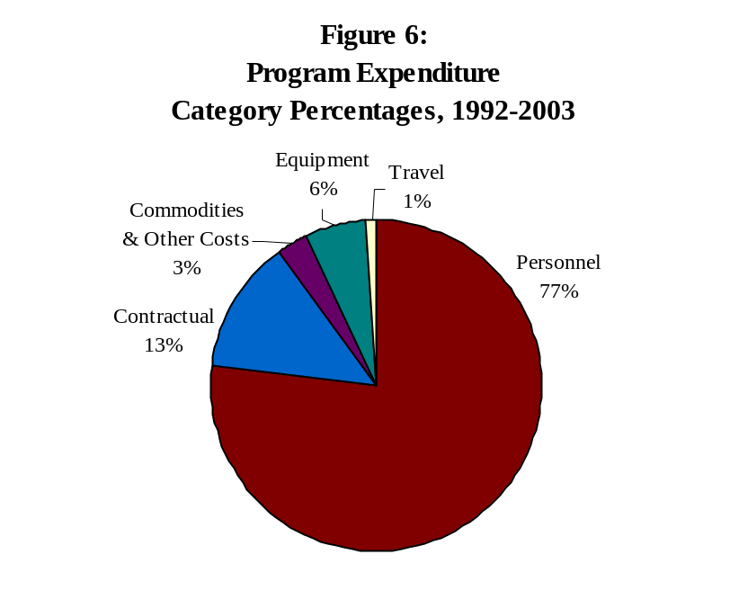

The chart above illustrates how the vast majority of the Council’s funds are used to support the people who make the programs work.

The Council’s grant programs currently support a total of 133 persons in 2002. This number includes:

~ 102 investigators and auditors that perform sworn and civilian investigative functions;
~ 11 assistant state’s attorneys prosecuting motor vehicle theft and insurance fraud cases;
~ 11 support personnel including data input operators, clerical support, and others; and,
~ 9 technical and professional positions including intelligence analysts, social workers, intake specialist and law
clerks.

Do grantees “match” Trust Funds?
It is important to note that nearly all of the funded programs also involve considerable “matching” from participating agencies. For example, in terms of the task forces, local agencies are reimbursed for officers assigned at an “entry level” salary as opposed to their actual salary.
The Illinois State Police and the Secretary of State Department of Police assigned seven task force directors and 26 other personnel to their programs without requesting funding. Similarly, the National Insurance Crime Bureau is not compensated for their personnel assigned to the programs.
Many agencies have also contributed office space and furnishings, surveillance equipment and vehicles, radios, and consumable supplies, even if they did not contribute personnel to the program. In other words, the programs funded by the Council are truly cooperative ventures.

Figure 7:
Ratio of Trust Funds to Match Funds, 2002
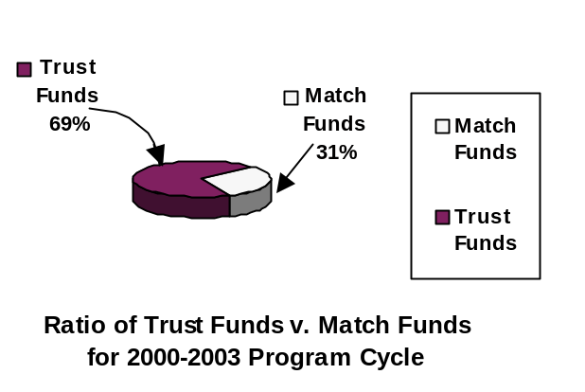

As indicated above, for programs that operate in 2003, local agencies will share 31 percent of the total program costs. The Council’s trust funds will cover 69 percent of total program costs.
The majority of awarded funds have gone into the law enforcement area. These funds have been earmarked chiefly to pay for law enforcement personnel - investigators. The Council’s funding strategy since 1992 is depicted in the following table:

Table 13:
Illinois Motor Vehicle Theft Prevention Council
Trust Funds Awarded SFY 1992 – SFY 2003
LAW ENFORCEMENT  - Multi-jurisdictional Task Forces  DuPage County BATTLE Auto Theft Task Force  Kane County Auto Theft Task Force (KCAT)  Lake County Auto Theft Task Force  Metro East Auto Theft Task Force (METT)  Northern Illinois Auto Theft Task Force (NIATF)  Northwestern Suburban Auto Theft Task Force (NSAT)  So. Suburban Auto Theft Task Force (SSATIN)  Tri-County Auto Theft Task Force  - Special Investigative Activities  Winnebago/Boone County ALERTS Theft Prevention Program  Prevention, Enforcement and Tracking Program (PET)  Peoria/Tazewell ALERTS Theft Prevention Program  SOS Police Special Audit Teams Program  Special SOS Audit Program - Insurance Pools  - Specialized Prosecution Units  Motor Vehicle Theft Prosecutions Program  Specialized Prosecution Unit | $36.1 million (49%)  $15.8 million (22%)  $6.3 million (9%)
LAW ENFORCMENT INFRASTRUCTURE  - Analysis/Sharing of criminal intelligence information  Motor Vehicle Theft Intelligence Clearinghouse  ALERTS Expansion Program  Chicago Motor Vehicle Theft Prevention Program  Strategic Motor Vehicle Theft Reduction Program  - Training  ISP Motor Vehicle Theft Prevention Training Program  Illinois Law Enforcement Training and Standards Board Motor Vehicle Theft Prevention Training Program  - Vehicles Loaned for programs  Insurance Vehicle Fund | $6.6 million (9%)  $1.3 million (2%)  $610,000 (1%)
PUBLIC EDUCATION AND AWARENESS  1994 Holiday Advertising Program  1995 Marketing Communications Program  Annual Training Seminar  Austin community Program  Beat Auto Theft (B.A.T.) Program - Secretary of State  Beat Auto Theft (B.A.T.) - Illinois Criminal Justice Information Authority  Persons with Disabilities Program  Project Park Smart  New Park Smart Program  Vehicle Etching Program | $3.3 million (5%)
Evaluation and Research  Evaluation of Mobile Data Terminal Technology  Evaluation of Motor Vehicle Theft Task Forces  Evaluation of SOS Special Audit Teams Program  Evaluation of Statewide Training Program  Evaluation of Vehicle for Change Program  Research in Motor Vehicle Theft | $415,845 (1%)
INNOVATIVE PROGRAMS  Operation Offender Identification  Park Forest Auto Theft Reduction Program  Vehicle for Change - Cook Co. State’s Attorney  Vehicle for Change - Metropolitan Family Services | $2.9 million (4%)
TOTAL - ALL PROGRAM AREAS | $73 million (100%)

Areas of greatest need
Motor vehicle theft data continues to indicate that the top five metropolitan areas of volume of motor vehicle theft, are:
1. The greater Chicago Metropolitan Area including Cook, DuPage, Kane, McHenry, and Lake Counties
2. The greater Joliet Metropolitan Area including Will, Grundy, and Kankakee Counties
3. The greater East St. Louis Metropolitan Area including St. Clair and Madison Counties
4. The greater Rockford Metropolitan Area including Winnebago and Boone Counties
5. The greater Peoria Metropolitan Area including Peoria, Tazewell, and Woodford Counties.

The Council has determined that an effective statewide strategy must include involve efforts in the areas of the state where the problem is most prevalent. Public hearing testimony and data analysis support the notion that motor vehicle theft is largely concentrated in the urban areas of the State.

The Council determines these five areas to be the areas in greatest need of motor vehicle theft prevention program activities for 2004-2007. Motor vehicle thefts in the counties of Cook, DuPage, Lake, Will, Kankakee, and Peoria dropped in 2001 from 1997, and the Peoria and Rockford metropolitan motor vehicle thefts also dropped during that period. To the extent feasible, all programs the Council funds should have a direct impact on the theft problem in these areas.

Table 14:

Percent Change and Funds Allocated For 2002 and 2003
Program | 2002 | 2003 | % Change
Secretary of State Special Audit Teams Program | $1,060,900 | $1,092,727 | 3%
Motor Vehicle Theft Prosecution Unit | $609,138 | $628,624 | 3%
Tri-County Auto Theft Task Force | $767,466 | $788,984 | 3%
Metro East Auto Theft Task Force | $589,172 | $589,172 | 0%
Kane County Auto Theft Task Force | $386,375 | $398,383 | 3%
South Suburban Auto Theft Interdiction Network | $783,756 | $788,844 | 1%
Insurance Vehicle Expense Fund Program | $65,000 | $65,000 | 0%
Motor Vehicle Theft Intelligence Clearinghouse | $262,978 | $270,630 | 3%
DuPage County Auto Theft Task Force (BATTLE) | $421,839 | $434,494 | 3%
Northern Illinois Auto Theft Task Force | $411,715 | $422,172 | 3%
Motor Vehicle Theft Investigation Training | $83,252 | $84,665 | 2%
Chicago Police Department Vehicle Theft Data Analysis | $123,954 | $127,523 | 3%
State and Local Auto Theft Enforcement | $92,476 | $93,900 | 2%
Unallocated funds | $394,109 | $448,426 | 14%
TOTAL | $6,052,130 | $6,233,544 | 3%

Conclusions
The goals of the 2004 - 2007 Statewide Motor Vehicle Theft Prevention Strategy are to prevent, combat, and reduce motor vehicle theft in Illinois; and to improve and support motor vehicle theft law enforcement, prosecution, and administration of motor vehicle theft laws by establishing statewide planning capabilities for and coordination of financial resources. The Council’s staff is charged with implementing this statewide strategy through encouraging, soliciting, and assisting program development efforts which address the priorities specified herein.
Limited Motor Vehicle Theft Prevention Trust Funds do not permit every identified problem to be addressed. Therefore, it is necessary to propose a strategy that can be implemented and that encourages programs that will show results within the life of the Trust Funds, that are affordable, and that will maximize the return on dollars that have already been invested to address the problem, and will be invested in the future.

APPENDIX A

THE ILLINOIS MOTOR VEHICLE THEFT PREVENTION ACT
(20 Illinois Compiled Statutes 4005)
4005/1 Title. This Act shall be known as the Illinois Motor Vehicle Theft Prevention Act.
4005/2 Purpose. The purpose of this Act is to prevent, combat and reduce motor vehicle theft in Illinois; to improve and support motor vehicle theft law enforcement, prosecution and administration of motor vehicle theft laws by establishing statewide planning capabilities for and coordination of financial resources.
4005/3 Definitions. As used in this Act:
(a) “Authority” means the Illinois Criminal Justice Information Authority.
(b) “Council” means the Illinois Motor Vehicle Theft Prevention Council, established within the Authority by this Act.
(c) “Trust Fund” means the Motor Vehicle Theft Prevention Trust Fund.

4005/4 Motor Vehicle Theft Prevention Council - Members - Chairman - Terms - Meetings. There is hereby created within the Authority an Illinois Motor Vehicle Theft Prevention Council, which shall exercise its powers, duties and responsibilities independently of the Authority. There shall be 11 members of the Council consisting of the Secretary of State or his designee, the Director of the Department of State Police, the State’s Attorney of Cook County, the Superintendent of the Chicago Police Department, and the following 7 additional members, each of whom shall be appointed by the Governor: a state’s attorney of a county other than Cook, a chief executive law enforcement official from a jurisdiction other than the City of Chicago, 5 representatives of insurers authorized to write motor vehicle insurance in this State, all of whom shall be domiciled in this State.
The Governor from time to time shall designate the Chairman of the Council from the membership. All members of the Council appointed by the Governor shall serve at the discretion of the Governor for a term not to exceed 4 years. The initial appointed members of the Council shall serve from January 1, 1991 until the third Monday in January, 1995 or until their successors are appointed. The Council shall meet at least quarterly.
4005/5 Compensation of Members. Members of the Council shall serve without compensation. All members shall be reimbursed for reasonable expenses incurred in connection with their duties.
4005/6 Personnel. The Executive Director of the Authority shall employ, in accordance with the provisions of the Illinois Personnel Code, such administrative, professional, clerical, and other personnel as may be required and may organize such staff as may be appropriate to effectuate the purposes of this Act.
4005/7 Powers and Duties of Council. The Council shall have the following powers, duties and responsibilities:
(a)To apply for, solicit, receive, establish priorities for, allocate, disburse, contract for, and spend funds that are made available to the Council from any source to effectuate the purposes of the Act;
(b)To make grants and to provide financial support for federal and state agencies, units of local government, corporations, and neighborhood, community and business organizations to effectuate the purposes of this Act;
(c)To assess the scope of the problem of motor vehicle theft, including particular areas of the state where the problem is greatest and to conduct impact analyses of state and local criminal justice policies, programs, plans and methods for combating the problem;
(d)To develop and sponsor the implementation of statewide plans and strategies to combat motor vehicle theft and to improve the administration of the motor vehicle theft laws and provide an effective forum for identification of critical problems associated with motor vehicle theft;
(e)To coordinate the development, adoption, and implementation of plans and strategies relating to interagency or intergovernmental cooperation with respect to motor vehicle theft law enforcement;
(f)To promulgate rules and regulations necessary to ensure that appropriate agencies, units of government, private organizations and combinations thereof are included in the development and implementation of strategies or plans adopted pursuant to the Act, and to promulgate rules or regulations as may otherwise be necessary to effectuate the purposes of the Act;
(g)To report annually, on or before April 1, 1992 to the Governor, General Assembly, and, upon request, to members of the general public on the Council’s activities in the preceding year; and
(h)To exercise any other powers that are reasonable, necessary, or convenient to fulfill its responsibilities, to carry out and to effectuate the objectives and purposes of the Council and the provisions of this Act, and to comply with the requirements of applicable federal or State laws or regulations; provided, however, that such powers shall not include the power to subpoena or arrest.
4005/8 Motor Vehicle Theft Prevention Trust Fund. (a)A special fund is created in the State Treasury known as the Motor Vehicle Theft Prevention Trust Fund, which shall be administered by the Executive Director of the Authority at the direction of the Council. All interest earned from the investment or deposit of monies accumulated in the Trust Fund shall, pursuant to Section 4.1 of the State Finance Act, be deposited in the Trust Fund.
(b)Money deposited in the Trust Fund shall not be considered general revenue of the State of Illinois.
(c)Money deposited in the Trust Fund shall be used only to enhance efforts to effectuate the purposes of this Act as determined by the Council and shall not be appropriated, loaned or in any manner transferred to the General Revenue of the State of Illinois.
(d)Prior to April 1, 1991, and prior to April 1 of each year thereafter, each insurer engaged in writing private passenger motor vehicle insurance coverages which are included in Class 2 and Class 3 of Section of the Illinois Insurance Code, as a condition of its authority to transact business in this State, may collect and shall pay into the Trust Fund an amount equal to $1.00, or a lesser amount determined by the Council, multiplied by the insurer’s total earned car years of private passenger motor vehicle insurance policies providing physical damage coverage written in this State during the preceding calendar year.
(e)Money in the Trust Fund shall be expended as follows:
(1)To pay the Authority’s costs to administer the Council and the Trust Fund, but for this purpose in an amount not to exceed ten percent in any one fiscal year of the amount collected pursuant to paragraph (d) of this Section in that same fiscal year.
(2)To achieve the purposes and objectives of this Act, which may include, but not be limited to, the following:
(A)To provide financial support to law enforcement and correctional agencies, prosecutors, and the judiciary for programs designed to reduce motor vehicle theft and to improve the administration of motor vehicle theft laws.
(B)To provide financial support for federal and state agencies, units of local government, corporations and neighborhood, community or business organizations for programs designed to reduce motor vehicle theft and to improve the administration of motor vehicle theft laws.
(C)To provide financial support to conduct programs designed to inform owners of motor vehicles about the financial and social costs of motor vehicle theft and to suggest to those owners methods for preventing motor vehicle theft.
(D)To provide financial support for plans, programs, and projects designed to achieve the purposes of this Act.
(f)Insurers contributing to the Trust Fund shall have a property interest in the unexpended money in the Trust Fund, which property interest shall not be retroactively changed or extinguished by the General Assembly.
(g)In the event the Trust Fund were to be discontinued or the Council were to be dissolved by act of the General Assembly or by operation of law, then, notwithstanding the provisions of Section 5 of the State Finance Act, any balance remaining therein shall be returned to the insurers writing private passenger motor vehicle insurance in proportion to their financial contributions to the Trust Fund and any assets of the Council shall be liquidated and returned in the same manner after deduction of administrative costs.
The Act is repealed effective January 1, 2004.
(Source: Public Act 86-1406, eff. January 1, 1991; as amended by Public Act 88-452, eff. January 1, 1994 and Public Act 89-277, eff. August 10, 1995.)
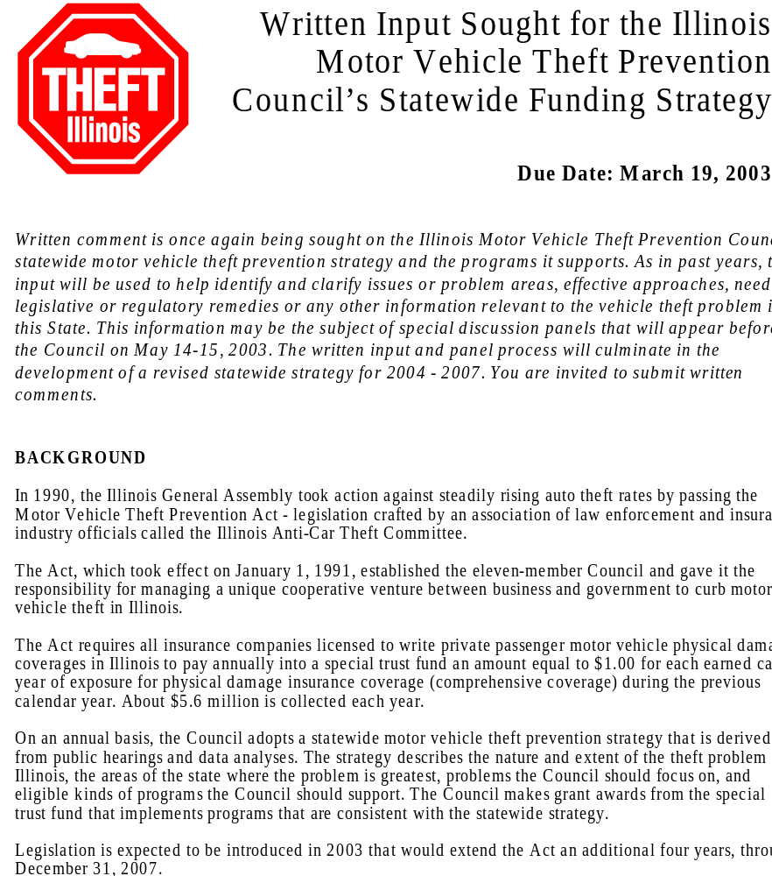

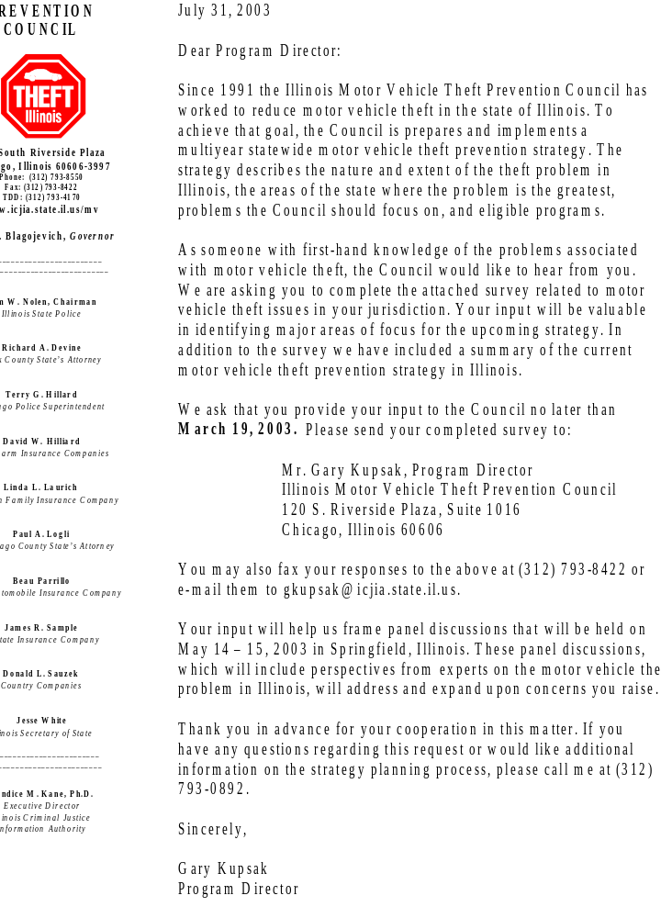
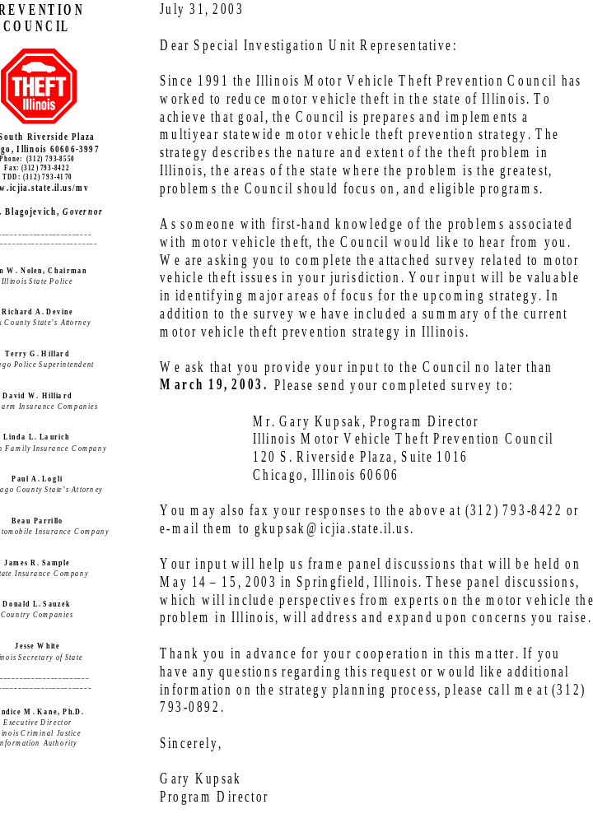
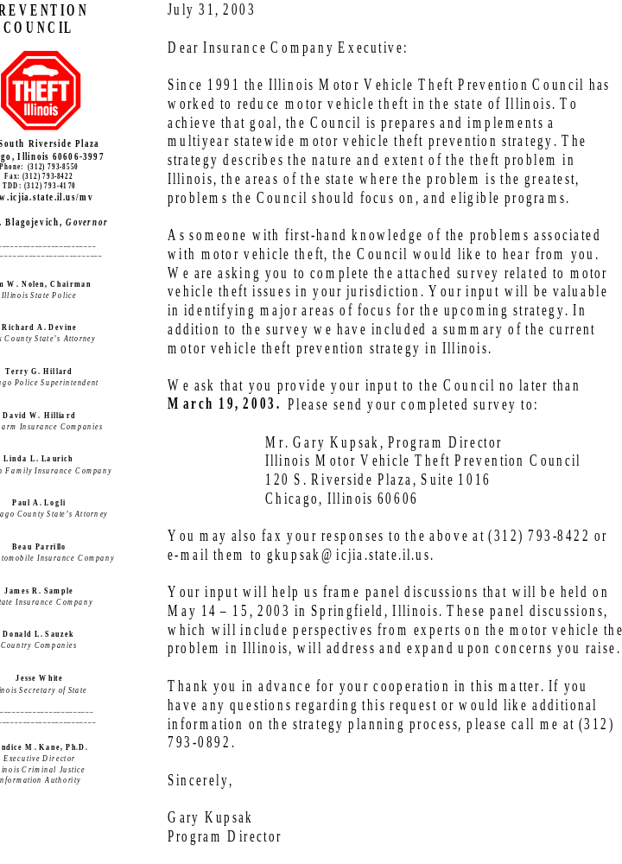
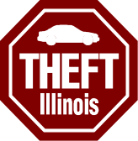
The Illinois Motor Vehicle Theft Prevention Council

Job Title:_____________________ Jurisdiction:________________________

The Council requests your input with regard to the Illinois Motor Vehicle Theft Prevention Council’s Strategy and the programs it supports. Please answer the following questions and return to the Illinois Motor Vehicle Theft Prevention Council:
YES NO

YES NO

YES NO

YES NO

YES NO

YES NO

YES NO
- Are you familiar with the Illinois Motor Vehicle Theft Prevention Council?

- Is the Council focusing its efforts on programs that will reduce vehicle theft in Illinois?

2a. If no, what changes do you recommend?
_________________________________________________________
_________________________________________________________

- Will the Council’s current efforts prevent vehicle theft in Illinois?

3a. If no, what changes do you recommend?
_________________________________________________________
_________________________________________________________

- Does the Council fund programs where the need for programs is the greatest?

4a. If no, what other areas should be targeted?
_________________________________________________________
_________________________________________________________

- On what activities do you think Council funds would be best spent (e.g., law enforcement, prosecution, data analysis, prevention/public awareness)?
_________________________________________________________
_________________________________________________________

- Are there additional vehicle theft problems that should be included in the vehicle theft prevention strategy (e.g., chop shops, gangs, new methods of vehicle theft)?

6a. If yes, what are they and why should they be included in the strategy?
_________________________________________________________
_________________________________________________________

- Would you eliminate any of the Council’s goals or objectives as stated in the current vehicle theft prevention strategy?

7a. If yes, which goals or objectives and why?
________________________________________________________
__________________________________________________________

- Are there any additional goals and objectives that should be added to the Council’s
vehicle theft prevention strategy?

8a. If yes, what are they and why should they be added?
__________________________________________________________
__________________________________________________________

Illinois Motor Vehicle Theft Prevention Council
Vehicle Theft Prevention Strategy Summary

BACKGROUND

In 1990, the Illinois General Assembly took action against steadily rising auto theft rates by passing the Motor Vehicle Theft Prevention Act - legislation crafted by an association of law enforcement and insurance industry officials called the Illinois Anti-Car Theft Committee.

The Act, which took effect on January 1, 1991, established the eleven-member Council and gave it the responsibility for managing a unique cooperative venture between business and government to curb motor vehicle theft in Illinois.

The Act requires all insurance companies licensed to write private passenger motor vehicle physical damage coverage in Illinois to pay annually into a special trust fund an amount equal to $1.00 for each earned car year of exposure for physical damage insurance coverage (comprehensive coverage) during the previous calendar year. About $5.6 million is collected each year.

At four-year intervals, the Council adopts a statewide motor vehicle theft prevention strategy that is derived from public hearings and data analyses. The strategy describes the nature and extent of the theft problem in Illinois, the areas of the state where the problem is greatest, problems the Council should focus on, and eligible kinds of programs the Council should support. The Council makes grant awards from the special trust fund that implements programs that are consistent with the statewide strategy.

Legislation is expected to be introduced in 2003 that would extend the Act an additional four years - through December 31, 2003.

Current Focus of Statewide Strategy

The current statewide motor vehicle theft prevention strategy is aimed at addressing the following problems:

1. The collection, analysis, accuracy, completeness and sharing of vehicle
theft statistical data and criminal intelligence.

2. The traditionally fragmented and uncoordinated response of the criminal
justice system to the motor vehicle theft problem.

3. Training of law enforcement, prosecutorial agencies, and others
combating vehicle theft.

4. Limited law enforcement resources.

5. Motor vehicle theft enterprises in some areas of the State involve dealers
of vehicle parts and scrap.
6. Insurance Fraud.

7. The complexity of criminal prosecutions.

8. Revised strategies to better fit youthful and habitual offenders.

- The lack of public awareness of motor vehicle theft and the public's
involvement in reduction and prevention efforts.

Geographic Areas of Greatest Need

The Council has focused its support on programs in the seven geographic areas of greatest need in terms of the nature and extent of the motor vehicle theft problem: the metropolitan areas of Chicago, East St. Louis, Joliet, Rockford, Peoria, DuPage County and Kane County.

Eligible Program Areas for Funding

Law enforcement - multi-jurisdictional task forces, special investigative programs, and specialized prosecution units.

The infrastructure supporting law enforcement efforts - the collection, analysis, and sharing of criminal intelligence information regarding motor vehicle theft; the development and implementation of training programs for law enforcement officers; training for state's attorneys and the judiciary; the development and implementation of training programs dealing with record keeping and theft prevention procedures aimed at vehicle related businesses and license-holders including salvage yards, rebuilders, recyclers, scrap processors, new and used car dealerships; and, building additional alliances with agencies and organizations involved in fighting vehicle theft and insurance fraud.

Public awareness - public education and prevention efforts which: inform owners about the financial and social consequences of motor vehicle theft; suggest methods for preventing such thefts; encourage the general public to report motor vehicle theft and related crimes; and highlight the work of task forces, special investigative activities and other efforts funded by the Council.

Evaluation and research - assessments of the administration and operation of funded programs as well as their impact on the motor vehicle theft problem; and, research supporting the identification and implementation of strategies for combating vehicle theft and insurance fraud.

Innovative programs - to encourage the development and implementation of creative and innovative approaches to respond to the motor vehicle theft problem in Illinois.

The Focus of Current Programs

Since March 1992 (when the first grant awards were made), the Council has awarded funds to programs designed to combat motor vehicle theft in Illinois. The programs include:

- several special multi-jurisdictional law enforcement task forces around the State which include special prosecutors;

- a statewide auditing program focused on vehicle and parts-related businesses, and insurance pools throughout Illinois;

- a statewide law enforcement training program;

- a statewide specialized crime analysis and intelligence gathering clearinghouse;

- a strategic theft reduction program in the City of Chicago based on computer mapping;

- program evaluation projects; and,

- a research project studying career auto thieves to help formulate more effective strategies for dealing with them.

How Trust Funds are Used

The Trust Funds awarded to date have been used chiefly to fund law enforcement personnel. A total of 138 persons are supported in the Council's grant programs during 2002.

These personnel include:
- 105 investigators and auditors who perform sworn and civilian investigative functions;
- 11 assistant state’s attorneys prosecuting motor vehicle theft and insurance fraud cases;
- 2 support personnel including data input operators, clerical support, and others; and,
- 10 technical and professional positions including intelligence analysts, social workers, intake specialist and law clerks.

Accomplishments of Funded Programs Reports maintained by the Illinois State Police indicate that the Council-funded multi-jurisdictional task forces conducted over 16,500 investigations from August 1992 through October 2002. The work of the Council-funded
task forces has resulted in approximately 7,000 arrests and 3,000 convictions.
During this time, the task forces recovered about 23,000 vehicles, resulting in an estimated recovery value of $149 million.

The Objectives of the Statewide Strategy

The objectives of the statewide strategy are:

1. To reduce the number of motor vehicles stolen in the State;

2. To increase the number of stolen motor vehicles recovered;

3. To increase the percentage of offenses for violations of motor vehicle theft laws which result in arrests;

4. To increase the percentage of offenses for violations of motor vehicle theft laws which result in criminal prosecutions;

5. To increase the percentage of offenses for violations of motor vehicle theft laws which result in convictions and jail or prison sentences; and

6. To reduce the recidivism of motor vehicle theft offenders.

APPENDIX C

PANEL DISCUSSIONS PROGRAM

ILLINOIS MOTOR VEHICLE THEFT PREVENTION COUNCIL

Panel Discussions for the Development of the

Statewide Motor Vehicle Theft Prevention Strategy

May 14-15, 2003
Illinois Motor Vehicle Theft Prevention Council
Hilton Hotel of Springfield
Springfield, Illinois 62701

AGENDA
TIME(s) | EVENT
DAY 1 – Wednesday, May 14, 2003

9:00 a.m. – 9:50 a.m. | Panel 1- Nature and Extent of Motor Vehicle Theft Problems in Illinois
10:00 a.m. - 10:50 a.m. | Panel 2- Auto Theft Initiatives Outside Illinois (Arizona, Michigan, Texas)
11:00 a.m. - 11:50 a.m. | Panel 3 – Motor Vehicle Theft and Auto Related Insurance Fraud (Insurance Company Management Perspective)
11:45 a.m. - 12:45 p.m. | Lunch
12:45 p.m. - 1:35 p.m. | Panel 4 – Motor Vehicle Theft and Auto Related Insurance Fraud (SIU Managers Perspective)
1:45 p.m. - 2:35 p.m. | Panel 5- Criminal Investigation of Motor Vehicle Theft and Auto Related Insurance Fraud
2:45 p.m. - 3:35 p.m. | Panel 6 – Prosecution of Motor Vehicle Theft and Auto Related Insurance Fraud
3:45 p.m. - 4:00 p.m. | Summary of the Days Hearing
DAY 2 – Thursday, May 15, 2003

9:00 a.m. - 9:50 a.m. | Panel 7- Effective Partnering with Motor Vehicle Related Businesses on Motor Vehicle Theft

PROGRAM

DAY 1 - Wednesday, May 14, 2003

Panel 1: Nature and Extent of Motor Vehicle Theft Problems in Illinois
Discussion Questions:
- From available data, what motor vehicle theft trends have we seen over the last several years?
- What kinds of vehicles (passenger vehicles, trucks, ATVs, construction equipment, etc.) are being stolen in Illinois? Are there any trends that are apparent in the kinds of vehicles that are being stolen in Illinois?
- What make/model of passenger vehicles are being stolen in Illinois? Are there any trends that are apparent in the make/model of these vehicles that are being stolen in Illinois?
- What make/models of passenger vehicles are being recovered and what make/models are not being recovered in the Illinois. Are there any implications that may be made from the types of vehicles being recovered and those not being recovered?
- Are there any apparent motivations behind motor vehicle theft in Illinois?
- What implications may be made from information regarding the nature and extent of the motor vehicle theft problem in Illinois that may have a direct bearing on the development of the Council’s statewide vehicle theft prevention strategy?
- What role do juveniles play in the nature and extent of the motor vehicle theft problem in Illinois?
- What role have public information (or the lack thereof) activities had on the nature and extent of the motor vehicle theft problem in the state?

Panel 2: Auto Theft Initiatives Outside Illinois (Arizona, Michigan, Texas)

Discussion Questions:
- Over the last five years, describe the trends in motor vehicle theft in your state.
- Describe the funding mechanism of your state’s motor vehicle theft prevention program and if there have been any recent challenges to the continued funding of the program.
- What types of vehicles (passenger vehicles, trucks, ATVs, construction equipment) are being stolen in your state? What make/model of passenger vehicles are most often being stolen?
- What has the vehicle “recovery” experience been in your state? Have any implications or trends been identified based on the types of vehicles being recovered?
- Please give a description of the type of program (s) that have had the most impact of the motor vehicle theft in your state?
- Please describe, if any, programs that may have originally been thought to have a positive effect on motor vehicle theft in your state, but proved to be less than successful.
- Describe you state’s public information/education activities, and what the perceived impact of those programs have been on the motor vehicle theft problem.
- Over the last several years have any formal evaluations of your program’s effectiveness been conducted? If evaluations have been conducted, what were the results?

Panel 3: Motor Vehicle Theft and Auto Related Insurance Fraud (Insurance Company Management Perspective)
Discussion Questions:
- What has been the value of Council funded activities to your company?
- Describe what you feel the major emphasis of Council funded activities should be over the next four years.
- What impact has the investigation of motor vehicle related insurance fraud had in your company?
- Is the investigation of motor vehicle related insurance fraud an area that should be included in the priorities of Council funded units, and should there be any limitations on the investigation of these crimes?
- Should the investigation of “identity theft,” as it relates to the theft of a motor vehicle be included in the focus of Council funded units?
- Are there any motor vehicle theft activities that you would not like to see Council funded units participate in?
- Since the inception of Council activities insurance companies have contributed stolen/recovered vehicles to Council funded units to be used in investigative activities. Do you feel that this program is still sound, or should other means of obtaining vehicle for task force usage be explored?
- What do you feel the emphasis on public information/education from Council funded activities should be?
- After over ten years of operating under the task force approach to reducing vehicle theft in the state, do you feel that it is the appropriate mechanism to address vehicle theft in Illinois, or do you have other suggestions?

Panel 4: Motor Vehicle Theft and Auto Related Insurance Fraud (SIU Managers Perspective)

Discussion Questions:
- Is there an effective partnership between the insurance industry and law enforcement in Illinois in combating auto theft and motor vehicle theft related insurance fraud?
- What law enforcement approaches to auto theft prevention seem effective? What approaches seem ineffective? Are there any untried approaches that you feel may be effective?
- What are your observations regarding the insurance industry program in which recovered stolen vehicles are provided to task force units for operations? Is this program still a viable means of providing vehicles for the task forces, or should some other means of obtaining vehicle be pursued?
- What activities related to the investigation of auto theft and motor vehicle related insurance fraud should task force directors focus on during the next four years.
- What part do you feel a public information/education program plays in the overall activities of the Illinois Motor Vehicle Theft Prevention Council?
- On a scale of 1 – 5 with one being very effective and five being not effective, rate the effectiveness of Council funded task forces as they relate to your responsibilities in the insurance industry. What training needs/skills do you feel task force officers and law enforcement officers in general could benefit by in investigating motor vehicle theft and motor vehicle related insurance fraud?

Panel 5: Criminal Investigation of Motor Vehicle Theft and Auto Related Insurance Fraud

Discussion Questions:
- How is the law enforcement community in Illinois addressing the problem of auto theft and auto related insurance fraud?
- What accomplishments have been made in dealing with auto theft related activities in Illinois over the last four years?
- What effect is identity theft having on auto theft activities in Illinois?
- Does the auto and insurance industry view these activities as serious auto theft activities, or are these activities classified as something other than theft?
- Should some action be taken to insure that these activities are classified as auto theft, and what do you propose that the action be?
- What impact have street gangs had on motor vehicle theft, and what should the focus of activities aimed at this problem be?
- What law enforcement approaches seem effective in dealing with the auto theft problem, what approaches seem ineffective, and what strategies do you feel will have the greatest impact on motor vehicle theft in Illinois over the next four years?
- What part do you feel public information/education programs should play in the investigation of motor vehicle related theft problems?
- What training needs do you feel will better prepare law enforcement officers for locating, investigating and preparing cases for the prosecution of motor vehicle theft offenses?

Panel 6: Prosecution of Motor Vehicle Theft and Auto Related Insurance Fraud
Discussion Questions:
- How does the nature and extent of the vehicle theft problem in Illinois affect the prosecution of these cases?
- What are the current difficulties in prosecuting motor vehicle theft cases and what additional problems are caused when someone else’s identity is used to acquire a vehicle?
- What are the most effective prosecutory strategies/techniques being employed with motor vehicle theft cases?
- What obstacles, if any, exist in the successful prosecution of vehicle theft and related cases?
- What are the implications of these issues for the Council’s statewide vehicle theft prevention strategy?
- What training needs/topics should be addressed in the Council’s statewide vehicle theft prevention strategy?
- What part do you feel that public information/education programs play in the prosecution of motor vehicle theft related cases?
- How effective have Council funded task forces been in providing the evidence/probable cause to obtain convictions for motor vehicle theft related cases? What training for these task force officers and law enforcement officers in general would enhance their ability to present more prosecutable cases to your office?

DAY 2 – Thursday, May 15, 2003

Panel 7: Effective Partnering with Motor Vehicle Related Businesses on Motor Vehicle Theft

- What role do vehicle-related businesses play in the vehicle theft problem in Illinois?
- What role do/should vehicle-related businesses play in strategies to address these problems?
- What federal/state legislative or regulatory initiatives may affect vehicle-related businesses?
- What is the industry’s reaction to the programs currently funded by the Council?
- What adjustments in the current programs funded by the Council relative to motor vehicle related businesses would you suggest?
- Do you feel a Council funded public information/education program would improve the benefit to motor vehicle related businesses? What should that program consist of?

APPENDIX D

COUNCIL-FUNDED PROGRAMS

ILLINOIS MOTOR VEHICLE THEFT PREVENTION COUNCIL

SUMMARY OF CURRENT PROGRAM

PROGRAM NAME | SOS Police Special Audit Teams
IMPLEMENTING ENTITY | Illinois Secretary of State, Department of Police
MOST RECENT AWARD AGREEMENT NUMBER | MV #02-001
IMPLEMENTATION DATE | September 1, 1992
END DATE | December 31, 2003
TOTAL FUNDS AWARDED TO DATE | $14,083,007
GEOGRAPHIC AREA TARGETED | Statewide
STAFF SUPPORTED BY PROGRAM | Thirty-one (31) persons, including fourteen (14) auditors, eight (8) supervisors, eight (8) data analysts, and one (1) fiscal officer
PROGRAM SUMMARY
The program was focused on a “marketplace” for stolen vehicle and parts – licensed salvage yards, rebuilders, repairers, and scrap processors. It involved an intensive audit program for compliance with regulations which govern these licensee’s record keeping concerning vehicle and vehicle part transactions.

Audit teams have established in Chicago, Westchester, East St. Louis, Peoria, and Rockford. The audits are aimed at: (a) reducing the number of stolen vehicles disposed through salvage yards, rebuilders, repairers, and scrap processors; (b) reducing the number of stolen and contraband essential vehicle parts sold to and through these businesses; (c) eliminating “chop shop,” “retagging,” and other organized theft operations operating in the State; and, (d) tracking the flow of salvage vehicle titles and force the conversion of these titles to junking certificates when appropriate.
PROGRESS SUMMARY
The teams have performed a total of 28,782 audits since 1992. All licensees were audited during the first twelve months. The teams are now focusing on re-auditing licensees where gross violations were previously found. The audits have resulted in the arrest 228 persons. A total of 880 stolen vehicles were recovered worth an estimated $5.8 million.

ILLINOIS MOTOR VEHICLE THEFT PREVENTION COUNCIL

SUMMARY OF CURRENT PROGRAM

PROGRAM NAME | Motor Vehicle Theft Prosecutions Unit
IMPLEMENTING ENTITY | Office of the State’s Attorney of Cook County
MOST RECENT AWARD AGREEMENT NUMBER | MV #02-004
IMPLEMENTATION DATE | August 23, 1992
END DATE | December 31, 2003
TOTAL FUNDS AWARDED TO DATE | $6,206,309
GEOGRAPHIC AREA TARGETED | Cook County
STAFF SUPPORTED BY PROGRAM | Eight (8) persons: One supervising State’s Attorney, three (3) Assistance State’s Attorneys, two (2) investigators, one (1) administrative assistant, and two (2) support staff.
PROGRAM SUMMARY
The program’s objective is to target career auto thieves: chop shop operations; insurance frauds; illegal activities of scrap, parts, and vehicle dealers; illegal activities of rebuilder shops; and organized street gang-related vehicle theft through investigations and referrals, and to prosecute the vehicle theft and fraud offenders. The unit is also charged with the duty of training felony assistant state’s attorneys.
PROGRESS SUMMARY
From 1992 – 2002, the unit has brought 1,272 indictments or informations against 1,554 defendants resulting in 1,250 convictions.

These defendants were sentenced to a total of 7,500 years in prison on vehicle theft and related charges.

The unit also provides ongoing training to other assistant state’s attorneys in the office.

ILLINOIS MOTOR VEHICLE THEFT PREVENTION COUNCIL

SUMMARY OF CURRENT PROGRAM

PROGRAM NAME | Northern Illinois Auto Theft Task Force
IMPLEMENTING ENTITY | County of Winnebago on behalf of the Sheriff’s Department
MOST RECENT AWARD AGREEMENT NUMBER | MV #02-025
IMPLEMENTATION DATE | November 1, 1993
END DATE | December 31, 2003
TOTAL FUNDS AWARDED TO DATE | $3,795,139
GEOGRAPHIC AREA TARGETED | Winnebago and Boone Counties
STAFF SUPPORTED BY PROGRAM | Ten (10) investigators; one (1) assistant state’s attorney and one (1) secretary. Contributing agencies have included the police departments of: Loves Park, Belvidere, and Cherry Valley; the sheriff’s departments of Winnebago and Boone Counties; the Winnebago County State’s Attorney’s office; Illinois State Police; and the Illinois Secretary of State’s Department of Police.
PROGRAM SUMMARY
Headed by a Secretary of State’s Department of Police lieutenant, this multi-jurisdictional auto theft task force conducts criminal investigations, gathers intelligence, processes recovered vehicles, apprehends offenders, and shares information with all law enforcement agencies in the two-county area.
The task force aims to increase the number of stolen vehicles, close local “chop shops,” and decrease insurance fraud.
PROGRESS SUMMARY
The task force launched 3,343 investigations, resulting in 1,266 arrests and 585 convictions. The Northern Illinois Auto Theft Task Force also recovered 5,092 stolen vehicles worth an estimated $24 million.

ILLINOIS MOTOR VEHICLE THEFT PREVENTION COUNCIL

SUMMARY OF CURRENT PROGRAM

PROGRAM NAME | DuPage County Auto Theft Task Force
IMPLEMENTING ENTITY | County of DuPage, Sheriff’s Police Department
MOST RECENT AWARD AGREEMENT NUMBER | MV #02-021
IMPLEMENTATION DATE | August 2, 1992
END DATE | December 31, 2003
TOTAL FUNDS AWARDED TO DATE | $4,431,767
GEOGRAPHIC AREA TARGETED | DuPage County
STAFF SUPPORTED BY PROGRAM | The DuPage County Auto Theft Task Force, known as B.A.T.T.L.E., Beat Auto Theft Through Law Enforcement, is composed of seven (7) investigators from the following law enforcement agencies: Illinois State Police, DuPage County Sheriff’s Office, Woodridge Police Department, Naperville Police Department, Winfield Police Department and the DuPage County State’s Attorney’s Office; one (1) Assistant State’s Attorney from DuPage County, and one (1) Clerk from the Sheriff’s Office.
PROGRAM SUMMARY
Officers in this task force conduct proactive and reactive investigations, focusing on individuals involved in organized motor vehicle theft activities. Techniques used include surveillance, use of confidential sources, and assistance from local police agencies or other task forces. Officers also supply manpower, intelligence data, and/or material support to members of local police departments in DuPage County, as well as surrounding auto theft task forces in a coordinated effort to reduce vehicle theft in Illinois.
PROGRESS SUMMARY
The task force has initiated 1,161 investigations, resulting in 719 arrests and 407 convictions. The unit has recovered 932 stolen vehicles worth an estimated $15 million.

ILLINOIS MOTOR VEHICLE THEFT PREVENTION COUNCIL

SUMMARY OF CURRENT PROGRAM

PROGRAM NAME | South Suburban Auto Theft Interdiction Network (SSATIN)
IMPLEMENTING ENTITY | Illinois State Police
MOST RECENT AWARD AGREEMENT NUMBER | MV #02-012
IMPLEMENTATION DATE | November 1, 1992
END DATE | December 31, 2003
TOTAL FUNDS AWARDED TO DATE | $6,533,994
GEOGRAPHIC AREA TARGETED | South suburban Cook County
STAFF SUPPORTED BY PROGRAM | 17 personnel, including 13officers assigned from the Illinois State Police; one officer from the, the Calumet City Police Department, Chicago Heights Police Department, Dolton Police Department, Harvey Police Department, and an agent from the National Insurance Crime Bureau are supported by the program. Two clerical positions are also supported, and one (1) support staff member.
PROGRAM SUMMARY
This task force serves the south suburban Cook County metropolitan area. Known as SSATIN, the unit employs numerous theft detection techniques, such as surveillance and informant development.
SSATIN utilizes “sting” operations and database tracking of offender information to identify chop shops and retagging operations, as well as thieves who specialize in the theft of heavy equipment or the use of fraudulent documents.
PROGRESS SUMMARY
SSATIN has initiated 1,779 criminal investigations, resulting in 1,538 arrests and 553 convictions. The unit recovered 2,130 stolen vehicles worth an estimated $35.8 million.

ILLINOIS MOTOR VEHICLE THEFT PREVENTION COUNCIL

SUMMARY OF CURRENT PROGRAM

PROGRAM NAME | Kane County Auto Theft Task Force
IMPLEMENTING ENTITY | City of Elgin
MOST RECENT AWARD AGREEMENT NUMBER | MV #02-011
IMPLEMENTATION DATE | August 24, 1992
END DATE | December 31, 2003
TOTAL FUNDS AWARDED TO DATE | $3,619,849
GEOGRAPHIC AREA TARGETED | Kane County
STAFF SUPPORTED BY PROGRAM | Six (6) investigators are supported from: the Illinois State Police, Elgin Police Department, Aurora Police Department, Kane County Sheriff’s Department, and assistant state’s attorney staff from the Kane County State’s Attorney’s office.
PROGRAM SUMMARY
This task force, known as KCAT, deals with a heavy dose of street gangs involved in vehicle theft and targets its suspects accordingly. Intelligence gathering, surveillance, and monitoring areas prone to thefts are part of the unit’s activities. One long-term investigation covered multi-county regions in Illinois and Wisconsin.
PROGRESS SUMMARY
KCAT has initiated 583 criminal investigations, resulting in 683 arrests and 294 convictions. The unit recovered 827 stolen vehicles worth an estimated $8.1 million.

ILLINOIS MOTOR VEHICLE THEFT PREVENTION COUNCIL

SUMMARY OF CURRENT PROGRAM

PROGRAM NAME | Metro East Auto Theft Task Force
IMPLEMENTING ENTITY | City of Belleville on behalf of the Police Department
MOST RECENT AWARD AGREEMENT NUMBER | MV #02-010
IMPLEMENTATION DATE | September 1, 1992
END DATE | December 31, 2003
TOTAL FUNDS AWARDED TO DATE | $6,632,899222
GEOGRAPHIC AREA TARGETED | Madison and St. Clair Counties
STAFF SUPPORTED BY PROGRAM | Fifteen (15) persons: one (1) director, two (2) uniformed officers, ten (10) undercover investigators, two (2) state’s attorneys, one (1) secretary and one (1) receptionist.
PROGRAM SUMMARY
Unique problems face the southern Illinois task force outside the East St. Louis metropolitan area. Vehicle thieves cross the Missouri-Illinois border with impunity. Working closely with the police departments of St. Louis and St. Louis County, the Metro East Auto Theft Task Force (METT) provides detection and apprehension of vehicle thieves who try to take advantage of jurisdictional boundaries.
Also unique is the assignment of two prosecutors to the unit from different counties.
PROGRESS SUMMARY
METT has initiated 5,496 criminal investigations, resulting in 2,211 arrests and 772 convictions. The unit recovered 3,054 stolen vehicles worth an estimated $22.9 million. The unit in their region identified a trend in carjackings in 1997: vehicles given up voluntarily to co-conspirators in exchange for “crack” cocaine or as overdue payment for drugs.

ILLINOIS MOTOR VEHICLE THEFT PREVENTION COUNCIL

SUMMARY OF CURRENT PROGRAM

PROGRAM NAME | Tri-County Auto Theft Task Force
IMPLEMENTING ENTITY | City of Joliet on behalf of the Police Department
MOST RECENT AWARD AGREEMENT NUMBER | MV #02-008
IMPLEMENTATION DATE | September 1, 1992
END DATE | December 31, 2003
TOTAL FUNDS AWARDED TO DATE | $7,280,283
GEOGRAPHIC AREA TARGETED | Will, Kankakee, and Grundy Counties
STAFF SUPPORTED BY PROGRAM | Seventeen (17) personnel assigned the Illinois State Police (12); and one (1) each from the Will County Sheriff’s Office, Joliet Police Department, the Grundy County Sheriff’s Office, the Kankakee County Sheriff’s Office, and the Romeoville Police Department. Two secretaries and one (1) agent from the National Insurance Crime Bureau are also supported.
PROGRAM SUMMARY
Task force officers focus their investigative efforts on career vehicle thieves, street gang members involved in vehicle theft, insurance fraud, chop shops, and illegal activities of salvage yards and vehicle repair shops.
Unwitting thieves who believe vehicles stolen in the urban areas served and dumped in the country are surprised to find a unit accustomed to covering a broad geographic region.
The unit also provides technical assistance to law enforcement agencies to develop their auto theft crime analysis capabilities.
PROGRESS SUMMARY
The task force initiated 3,397 criminal investigations resulting in 1,168 arrests and the conviction of 455 vehicle thieves. The task force has recovered 2,854 stolen vehicles worth an estimated $22.4million.

ILLINOIS MOTOR VEHICLE THEFT PREVENTION COUNCIL

SUMMARY OF CURRENT PROGRAM

PROGRAM NAME | State and Local Auto Theft Enforcement Task Force
IMPLEMENTING ENTITY | City of Peoria on behalf of the Peoria Police Department
MOST RECENT AWARD AGREEMENT NUMBER | MV #02-040
IMPLEMENTATION DATE | January 1, 2000
END DATE | December 31, 2003
TOTAL FUNDS AWARDED TO DATE | $466,544
GEOGRAPHIC AREA TARGETED | Peoria County
STAFF SUPPORTED BY PROGRAM | Eight personnel, including one Illinois State Police Lieutenant, one Illinois State Police Master Sergeant, one Illinois State Police investigator, an Illinois Secretary of State investigator, two Peoria City Police Department investigators, one Peoria County Sheriff’s Department investigator and one clerk.
PROGRAM SUMMARY
The State and Local Auto Theft Enforcement Task Force, or SLATE, operates in Peoria County which ranks seventh in the state for auto theft. Thefts in Peoria County include thefts by juvenile gang members, drug trades, re-tagging operations and for the purpose of insurance fraud.
The task force continues to work established partnerships within the law enforcement community. This coordination and joint effort helps all of the participating agencies target street gangs that are responsible for the majority of auto thefts in the Peoria area.
Officers also provide public education forums to instruct individuals on how to prevent motor vehicle theft. Information about motor vehicle thefts and suspected offenders is compiled and maintained on a computer network that other local agencies can share.
PROGRESS SUMMARY
The task force has initiated 446 criminal investigations resulting in 632 arrests and the conviction of 136 vehicle thieves. The task force has recovered 281 stolen vehicles worth an estimated $1.9 million.

ILLINOIS MOTOR VEHICLE THEFT PREVENTION COUNCIL

SUMMARY OF CURRENT PROGRAM

PROGRAM NAME | Motor Vehicle Theft Intelligence Clearinghouse
IMPLEMENTING ENTITY | Illinois State Police
MOST RECENT AWARD AGREEMENT NUMBER | MV #02-019
IMPLEMENTATION DATE | July 1, 1992
END DATE | December 31, 2003
TOTAL FUNDS AWARDED TO DATE | $2,596,640
GEOGRAPHIC AREA TARGETED | Statewide
STAFF SUPPORTED BY PROGRAM | The unit is comprised of three criminal intelligence analysts and two support personnel and is directed by a sergeant assigned by the Illinois State Police.
PROGRAM AND PROGRESS SUMMARY
The Motor Vehicle Theft Intelligence Clearinghouse is an infrastructure program that provides focused statewide analytical support for motor vehicle theft task forces and the Illinois law enforcement communities. Requests are for information, crime analysis, mapping, charting, case assistance, and the production of strategic products.
These requests included inquiries from auto theft task forces, the Illinois State Police, federal agencies; including the FBI, U.S. Customs, DEA, and IRS, and other criminal justice entities. The requests varied from simple name checks and title histories to the production of detailed motor vehicle theft regional assessments and lengthy analysis of auto theft conspiracy cases. Since 1992, the Clearinghouse has processed 3,083 requests, conducted Annual Statewide Assessments and completed monthly, quarterly and annual activity summaries concerning the task forces.

ILLINOIS MOTOR VEHICLE THEFT PREVENTION COUNCIL

SUMMARY OF CURRENT PROGRAM

PROGRAM NAME | Motor Vehicle Theft Training Program
IMPLEMENTING ENTITY | Illinois State Police, Training Academy
MOST RECENT AWARD AGREEMENT NUMBER | MV #02-036
IMPLEMENTATION DATE | September 1, 1996
END DATE | December 31, 2003
TOTAL FUNDS AWARDED TO DATE | $603,444
GEOGRAPHIC AREA TARGETED | Statewide
STAFF SUPPORTED BY PROGRAM | Since 1997, the program supported one (1) contract facilitator and one (1) clerical staff person. One (1) state police special agent oversees the program.
PROGRAM SUMMARY
Officer training is crucial to the success of vehicle theft detection and prosecution. The auto theft training program for law enforcement officers has been revised and refined over the six years since its inception. The Illinois Law Enforcement Standards and Training Board was the initial grantee. Courses were offered at three levels of expertise in vehicle theft prevention training for officers.

PROGRESS SUMMARY
In 1996, the Illinois State Police was awarded the grant and revised the program to include five 36-hour auto theft investigator courses that targeted Council-funded vehicle theft task forces. To assist in the teaching of the program, Illinois State Police officers, National Insurance Crime Bureau task force officers and the Secretary of State police were utilized as instructors. Since the inception of the program in 1996, 1,779 officers have received training. The expansion of training and locations was the result of feedback by the state police districts and local agencies.
The Illinois State Police advertised training schedules for the investigator and patrol officer programs through various means; a Type III LEADS message was sent to all Illinois chiefs, sheriffs and state police district commander, and a brochure was distributed to the Council, task force directors, state’s attorneys, sheriffs and chiefs of police associations, state police district commanders and other law enforcement associations. A survey on the training received positive acclaim from the chiefs and sheriffs.

ILLINOIS MOTOR VEHICLE THEFT PREVENTION COUNCIL

SUMMARY OF CURRENT PROGRAM

PROGRAM NAME | Insurance Vehicle Expense Fund
IMPLEMENTING ENTITY | Illinois Anti-Car Theft Committee
MOST RECENT AWARD AGREEMENT NUMBER | MV #02-016
IMPLEMENTATION DATE | November 1, 1992
END DATE | December 31, 2003
TOTAL FUNDS AWARDED TO DATE | $610,070
GEOGRAPHIC AREA TARGETED | Statewide
STAFF SUPPORTED BY PROGRAM | One ICJIA contractual specialist is assigned and supported by this program.
PROGRAM SUMMARY
To support Council-funded law enforcement efforts, insurance companies have loaned vehicles for use by Council-funded programs. To date, nearly two dozen insurance companies have loaned 213 vehicles.
The program’s funds are used to repair or purchase parts for these vehicles to make them safe for grantee’s operation. Most loaned vehicles are used by the task forces for surveillance and undercover activities.
The vast majority of these vehicles were recovered stolen vehicles obtained from the insurance salvage pools in the Chicago metropolitan area. About three-quarters of the loaned vehicles require repair. Funds are used to repair these often-damaged vehicles as well as to obtain required Illinois titles and license plates.

PROGRESS SUMMARY
Thus far, expenditures from the fund total approximately $450,000. There were approximately 94 vehicles in use in 2002. The Council spends about $65,000 per year to prepare vehicles for use. The estimated cost of leasing 94 vehicles for the year would have been $564,000.

APPENDIX E

Acuity A Mutual Insurance Company
Addison Insurance Company
Aegis Royal Insurance Company
Affirmative Insurance Company
All America Insurance Company
All Nation Insurance Company
Allied Property & Casualty Insurance Company
Allmerica Financial Alliance Insurance Company
Allmerica Financial Benefit Insurance Company
Allstate Indemnity Company
Allstate Insurance Company
Allstate Property & Casualty Insurance Company
Alpha Property & Casualty Insurance Company
AMCO Insurance Company
American & Foreign Insurance Company
American Access Casualty Company
American Ambassador Casualty Company
American Bankers Insurance Company of Florida
American Economy Insurance Company
American Employers Insurance Company
American Family Mutual Insurance Company
American Fire & Casualty Company
American Freedom Insurance Company
American General Indemnity Company
American Heartland Insurance Company
American Horizon Property & Casualty Insurance Company
American International Insurance Company
American International South Insurance Company
American Manufacturers Mutual Insurance Company
American Modern Home Insurance Company
American Motorists Insurance Company
American National General Insurance Company
American National Property & Casualty Company
American Premier Insurance Company
American Protection Insurance Company
American Safety Casualty Insurance Company
American Select Insurance Company
American Service Insurance Company Incorporated
American Standard Insurance Company of Wisconsin
American States Insurance Company
American States Preferred Insurance Company
American Union Insurance Company
AMEX Assurance Company
Amica Mutual Insurance Company
Apollo Casualty Company
Arch Insurance Company
Argonaut Insurance Company
Armed Forces Insurance Exchange
Assurance Company of America
Atlanta Casualty Company
Atlanta Specialty Insurance Company
Atlantic Mutual Insurance Company
Auto Club Family Insurance Company
Auto-Owners Insurance Company
Automobile Club International Exchange
Badger Mutual Insurance Company
Bankers Insurance Club
Bristol West Insurance Club
California Casualty Indemnity Exchange
Centennial Insurance Company
Central Mutual Insurance Company
Charter Oak Fire Insurance Company
Chicago Insurance Company
Chicago Motor Club Insurance Company
Chicago Mutual Insurance Company
Chubb National Insurance Company
Cincinnati Casualty Company
Cincinnati Indemnity Company
Cincinnati Insurance Company
Citizens Insurance Company of America
Citizens Insurance Company of Illinois
Columbia Mutual Insurance Company
Combined Specialty Insurance Company
Commerce and Industry Insurance Company
Constitutional Casualty Company
Continental Insurance Company
Continental National Indemnity Company
Continental Western Insurance Company
Country Casualty Insurance Company
Country Mutual Insurance Company
Country Preferred Insurance Company
Dairyland Insurance Company
Deerbrook Insurance Company
Depositors Insurance Company
Economy Fire & Casualty Company
Economy Preferred Insurance Company
Economy Premier Assurance Company
Electric Insurance Company
EMCASCO Insurance Company
Empire Fire & Marine Insurance Company
Employers Fire Insurance Company
Employers Mutual Casualty Company
Equity Mutual Insurance Company
Erie Insurance Company
Erie Insurance Exchange
Farmers Automobile Insurance Association
Farmers Union Cooperative Insurance Company
Federal Insurance Company
Federated Mutual Insurance Company
Fidelity & Casualty Company of New York
Fidelity & Guaranty Insurance Company
Fidelity & Guaranty Insurance Underwriters Incorporated
Financial Indemnity Company
First Liberty Insurance Company
First National Insurance Company of
America
Foremost Insurance Company
Foremost Property & Casualty Insurance Company
Foremost Signature Insurance Company
Founders Insurance Company
Gallant Insurance Company
GE Auto & Home Assurance Company
GEICO Casualty Company
GEICO General Insurance Company
GEICO Indemnity Company
General Casualty Company of Illinois
General Casualty Company of Wisconsin
General Insurance Company of American
Glens Fall Insurance Company
Globe American Casualty Company
Globe Indemnity Company
GMAC Insurance Company Online Incorporated
Goodville Mutual Casualty Company
Government Employees Insurance Company
Grange Indemnity Insurance Company
Grange Mutual Casualty Company
Granite State Insurance Company
Great American Alliance Insurance Company
Great American Assurance Company
Great American Contemporary Insurance Company
Great American Insurance Company
Great American Insurance Company of NY
Great American Royal Insurance Company
Great American Spirit Insurance Company
Great Northern Insurance Company
Grinnell Mutual Reinsurance Company
Grinnell Select Insurance Company
GuideOne America Insurance Company
GuideOne Elite Insurance Company
GuideOne Mutual Insurance Company
GuideOne Specialty Mutual Insurance Company
Hanover Insurance Company
Harleysville Insurance Company
Harleysville Lake States Insurance Company
Hartford Accident & Indemnity Company
Hartford Casualty Insurance Company
Hartford Fire Insurance Company
Hartford Insurance Company of Illinois
Hartford Insurance Company of The Midwest
Hartford Underwriters Insurance Company
Hastings Mutual Insurance Company
Homeland Central Insurance Company
Horace Mann Insurance Company
Horace Mann Property & Casualty Insurance Company
Illinois EMCASCO Insurance Company
Illinois Farmers Insurance Company
Illinois National Insurance Company
IMT Insurance Company Mutual
Indiana Insurance Company
Infinity Insurance Company
Insurance Company of the State of Pennsylvania
Insura Property & Casualty Insurance Company
Integon Casualty Insurance Company
Integon Indemnity Corporation
Integon National Insurance Company
Interstate Bankers Casualty Company
Interstate Indemnity Company
Iowa Mutual Insurance Company
Jefferson Insurance Company
Kemper Auto & Home Insurance Company
Liberty Insurance Corporation
Liberty Mutual Fire Insurance Company
Liberty Mutual Insurance Company
Lincoln General Insurance Company
Lumbermens Mutual Casualty Company
Lyndon Property Insurance Company
Madison Mutual Insurance Company
Markel American Insurance Company
Maryland Casualty Company
Massachusetts Bay Insurance Company
Medmarc Casualty Insurance Company
Mendakota Insurance Company
Merastar Insurance Company
Mercury Indemnity Company of Illinois
Mercury Insurance Company of Illinois
Meridian Royal Insurance Company
Metropolitan Casualty Insurance Company
Metropolitan Direct Property & Casualty Insurance Company
Metropolitan General Insurance Company
Metropolitan Group Property & Casualty Insurance Company
Metropolitan Property & Casualty Insurance Company
MIC General Insurance Corporation
Mid-Century Insurance Company
Midway Insurance Company of Illinois
Millers Classified Insurance Company
Millers Mutual Insurance Association
Milwaukee Casualty Insurance Company
Milwaukee Safeguard Insurance Company
Mutual Service Casualty Insurance Company
National Alliance Insurance Company
National Ben Franklin Insurance Company of Illinois
National Farmers Union Property & Casualty Company
National Farmers Union Standard Insurance Company
National General Assurance Company
National General Insurance Company
National Heritage Insurance Company
National Interstate Insurance Company
Nationwide Assurance Company
Nationwide General Insurance Company
Nationwide Insurance Company of American
Nationwide Mutual Fire Insurance Company
Nationwide Mutual Insurance Company
New Hampshire Insurance Company
North Pointe Insurance Company of Illinois
Northern Assurance Company of America
Northern Insurance Company of New York
Northland Insurance Company
Northwestern National Casualty Company
Oak Casualty Insurance Company
Ohio Casualty Insurance Company
Ohio Farmers Insurance Company
Ohio Royal Insurance Company
Old Republic Minnehoma Insurance Company
Omaha Property & Casualty Insurance Company
Omni Indemnity Company
Omni Insurance Company
One Beacon America Insurance Company
Owners Insurance Company
Pacific Indemnity Company
Pekin Insurance Company
Pennsylvania General Insurance Company
Pharmacists Mutual Insurance Company
Phoenix Insurance Company
Potomac Insurance Company of Illinois
Progressive American Insurance Company
Progressive Casualty Insurance Company
Progressive Halcyon Insurance Company
Progressive Premier Insurance Company of Illinois
Progressive Specialty Insurance Company
Progressive Universal Insurance Company of Illinois
Property & Casualty Insurance Company of Hartford
Providence Washington Insurance Company
Prudential Commercial Insurance Company
Prudential General Insurance Company
Prudential Property & Casualty Insurance Company
Redland Insurance Company
Regent Insurance Company
Republic Western Insurance Company
Response Insurance Company
Rockford Mutual Insurance Company
Royal Indemnity Company
Royal Insurance Company of American
Royal Insurance Company of Hartford
Royal National Insurance Company
SAFECO Insurance Company of American
SAFECO Insurance Company of Illinois
SAFECO National Insurance Company
Safeguard Insurance Company
Safeway Insurance Company
Sagamore Insurance Company
Selective Insurance Company of The Southeast
Sentry Insurance A Mutual Company
Shelby Insurance Company
Shelter General Insurance Company
Shelter Mutual Insurance Company
Sirius America Insurance Company
Southern Heritage Insurance Company
Springfield Fire & Casualty Company
St Paul Fire & Marine Insurance Company
St Paul Guardian Insurance Company
St Paul Insurance Company of Illinois
St Paul Mercury Insurance Company
Standard Mutual Insurance Company
State Auto National Insurance Company
State Auto Property & Casualty Insurance Company
State Automobile Mutual Insurance Company
State Farm Fire And Casualty Company
State Farm Mutual Auto Insurance Company
Stonington Insurance Company
Superior Insurance Company
Teachers Insurance Company
Tokio Marine & Fire Insurance Company Ltd., US Branch
Travco Insurance Company
Travelers Casualty Company of Connecticut
Travelers Home & Marine Insurance Company
Travelers Indemnity Company
Travelers Indemnity Company of American
Travelers Indemnity Company of Illinois
Travelers Property & Casualty Insurance Company of Illinois
Travelers Property Casualty Insurance Company
Tri State Insurance Company of Minnesota
Trinity Universal Insurance Company
Trustguard Insurance Company
Twin City Fire Insurance Company
Underwriters At Lloyds London
Unique Insurance Company
United Automobile Insurance Company
United Equitable Insurance Company
United Financial Casualty Company
United Fire & Casualty Company
United Royal Insurance Company
United Services Auto Association
United States Fidelity & Guaranty Company
Universal Casualty Company
Universal Underwriters Insurance Company
US Agencies Direct Insurance Company
USAA Casualty Insurance Company
USAA General Indemnity Company
Valiant Insurance Company
Victoria Fire & Casualty Company
Victoria Select Insurance Company
Vigilant Insurance Company
Viking Insurance Company of Wisconsin
Voyager Property & Casualty Insurance Company
Warner Insurance Company
Wausau Underwriters Insurance Company
West American Insurance Company
West Bend Mutual Insurance Company
Western Specialty Insurance Company
Western States Insurance Company
Westfield Insurance Company
Westfield National Insurance Company
Windsor Insurance Company
Worldwide Direct Auto Insurance Company
York Insurance Company
Yosemite Insurance Company
Young American Insurance Company

Hispanic and non-Hispanic are ethnic, whereas white and black are racial, distinctions. These numbers are therefore not broken down into the distinct categories understood by the population at large, white, black or Hispanic. Citizens are understood to be racially white or black and ethnically Hispanic or non-Hispanic by the U.S. government.
Due to the vehicle acquisition specialist position being vacant until late in the year, the remainder of the grant money was not spent in 2002.

